6th June 2025

Dear Parents/ Carers,

**OPAL – Sandpit Day 13th June 2025**

As you know we have been implementing many changes to how the children play here in school.

Our latest change is our new sandpit, which Mr. Daniels has built. He has worked so hard, and we are very grateful to him and all his efforts.

The children are delighted with this and will be able to play in this huge sandpit throughout the year (weather dependent).

In order for the sandpit to be fun we need resources, so we are going to hold a non-uniform day with the theme being ‘Come dressed for a day on the sand!’

Children are able to come into school in shorts, t-shirts etc and each class will have a timetabled slot in the huge sandpit.

Instead of asking for a donation of money, we ask that each child brings in something that you could use to play with on the sand eg a bucket, a spade, sieve, rake etc.

If you have more than one child in school this can be one item per family.

This day is also ‘Wear Yellow’ Day to raise awareness of Cystic Fibrosis. As we have been asked to take part in this, we thought it would be a great idea to combine both together. Therefore, as yellow is the colour of sunshine the children can wear yellow if they prefer.

This will be a lovely fun day, and we know how generous our parents are and so we thank you in anticipation of your usual support.

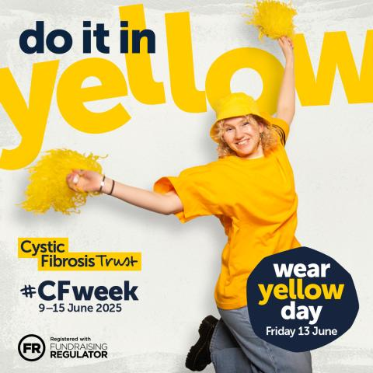Yours sincerely,

A Heston

Mrs Heston

DeputyHeadteacher