**Our Lady of Perpetual Succour**

**Catholic Primary School**

**Art and Design Policy**



**We learn to love everyone as Jesus loves us**

**Intent**

At Our Lady’s we believe that Art and Design express some of the highest forms of creativity. A high-quality Art education should engage, inspire and challenge children equipping them with the knowledge and skills to experiment, invent and create their own works of art, craft and design. As children progress, they should be able to think critically and develop a more rigorous understanding of Art and Design. They should also know how it reflects and shapes our history and contributes to the culture, creativity and wealth of our nation.

Children are encouraged to be spontaneously creative, using a variety of media and techniques in art and craft work. An awareness of colour, shape, balance, focus and proportion are developed alongside how to convey ideas and feelings. The study of a wide range of artists, craftspeople and designers also complement this work.

**National Curriculum - Art**

**Aims**

The national curriculum for Art aims to ensure that all pupils should be taught:

* To use a range of materials creatively to design and make products.
* To use drawing, painting and sculpture to develop and share their ideas, experiences and imagination.
* To develop a wide range of art and design techniques in using colour, pattern, texture, line, shape, form and space about the work of a range of artists, craft makers and designers, describing the differences and similarities between different practices and disciplines, and making links to their own work.
* To develop their techniques, including their control and their use of materials, with creativity, experimentation and an increasing awareness of different kinds of art, craft and design.
* To create sketch books to record their observations and use them to review and revisit ideas to improve their mastery of art and design techniques, including drawing, painting and sculpture with a range of materials (for example, pencil, charcoal, paint, clay) about great artists, architects and designers in history.

We teach a bespoke personalised broad and balanced curriculum. This curriculum is highly relevant to our pupils' needs here at Our Lady’s and thoroughly engages them as they tackle challenging and inspiring topics.

**Why is Art Important?**

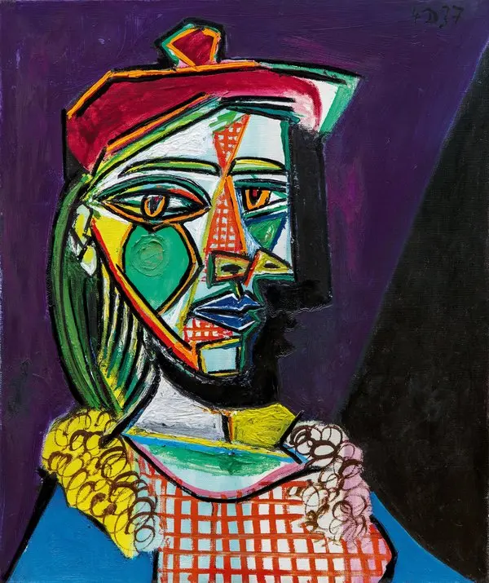Art education has proven to have remarkable impacts on academic, social and emotional outcomes, helping us develop empathy as we learn more about societies, cultures and history. Engagement with Art helps us stretch our minds beyond the boundaries of the printed text or the rules of what is provable to encompass visual, spatial learning and develop motor skills. Through Art we learn to express ourselves confidently and creatively.

**Pablo Picasso**

“Painting is poetry that is seen rather than felt and poetry is painting that is felt rather than seen”

"Art washes away from the soul the dust of everyday life”

**Every child is an artist. The problem is how to remain an artist when they grow up.**

**Pablo Picasso**

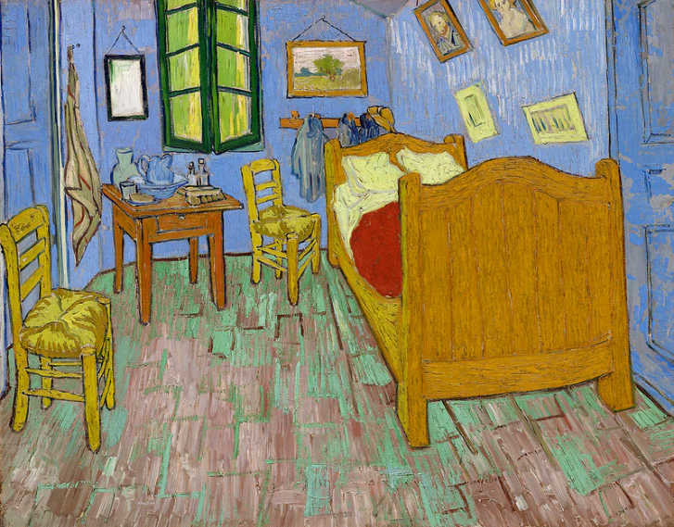**Vincent Van Gogh**

“Great things are done by a series of small things brought together.”

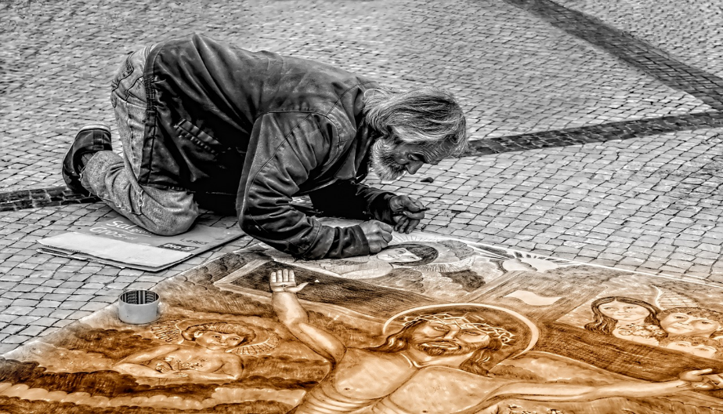

**Leonardo Da Vinci**

“Painting is poetry that is seen rather than felt, and poetry is painting that is felt rather than seen.”

* Through Art pupils produce their own original, creative work, exploring their ideas and recording their experiences.
* Art allows pupils to extend their imagination and reflect on their inner thoughts and feelings.
* Art creates opportunities to explore different materials and develop their own ideas and how to use them effectively.
* Art takes pupils to other worlds, cultures and times, as they explore ideas in the work of a variety of artists.
* Art helps pupils to begin to develop an understanding of how it reflects and shapes our society.
* Art engages, inspires and challenges pupils equipping them with the knowledge and skills to experiment and invent.

**Implementation**

**When is Art taught?**

Art is taught through our personalised and bespoke curriculum for Our Ladys. Art is taught each week and allows for the development and progression of knowledge, skills, vocabulary and understanding within Art and Design.

**How is Art taught?**

Art is related to topic work or other cross-curricular subjects and teachers plan specific activities and sequences of lessons to provide development of the skills, knowledge and understanding of the subject. Learning takes place both inside and outside the classroom.Children learn about a variety of different artists and their techniques for producing individual pieces, as well as designers and architects. Sketchbooks are used as a way of recording, developing skills and reflecting on their own work, as well as reflecting on artist’s work. It is important that children are exposed to the diversity of art that exists around the world. Art sketchbooks are used as a way of exploring responses to a variety of stimuli. Children at Our Ladys can explore their ideas and thoughts, through annotations, and develop their ideas further in their sketchbook. Sketchbook work then leads to a final piece of work.

The children at Our Ladys are encouraged to:

* Consider their own attitudes, values and feelings in relation to images and artefacts.
* Develop respect for their own and others’ work and learn how to offer and receive constructive feedback and praise.
* Test out their ideas and try different techniques using a range of media in their art sketchbooks.
* Work with others, listening to and respecting each other’s ideas, and learning to value different strengths and interests within the group.
* Develop a respect for the materials and resources that they use in their work, and learn to evaluate critically their own and others’ use of these.
* Investigate and make something whilst exploring and developing ideas, and evaluating and developing work.
* Evaluate their own ideas and methods, and the work of others, and say what they think and feel about them.
* Use a wide range of materials and resources, including ICT.

In the Early Years, children are able to use their imagination and be creative through a wide variety of activities set up within continuous provision in the indoor and outdoor environment. Expressive Arts and Design is taught through play and activities linked to their topic, that develop children’s creativity and encourage them to explore and express their ideas using a range of resources.

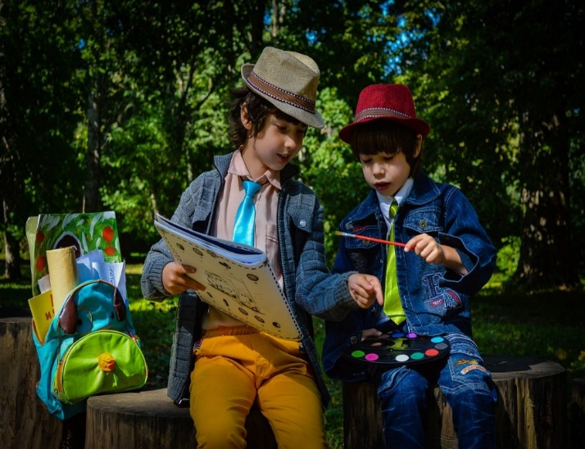When teaching Art and Design pupils are encouraged to be creative, imaginative whilst building their confidence to use new ideas and techniques. Pupils work individually, in pairs as well as in small groups. The teaching of Art is planned to ensure progression of skills, knowledge and understanding throughout each Key Stage.

**Art is an important part of developing pupils’ ability to express their individual creativity, working both individually and collaboratively with others.**

**What do we learn about in Art?**

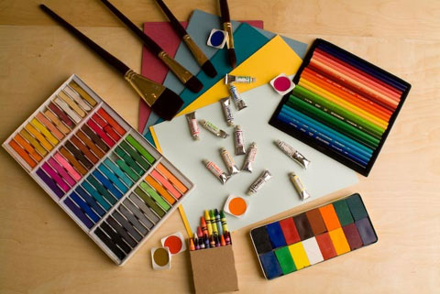In Art we learn about:

Different Media

* Drawing/Sketching
* Painting
* Textiles and collage
* Mixed Media
* 3D form
* Pattern
* Printing
* Sculpture
* Clay/Modelling

Through art, pupils produce their own, original creative work, exploring their ideas and recording their experiences.

Different Skills

* Explore line, shape and colour
* Explore a variety of tools and techniques
* Make marks in print with a variety of objects
* Investigate using print on a wide range of media
* Explore malleable materials
* Respond to ideas
* Make changes to own work
* Experiment using a variety of tools, including pencils, crayons, pastels, charcoal etc
* Use different brush sizes and shapes
* Build repeated patterns
* Work out ideas for drawings using sketchbooks
* Find out about artists and architects and designers
* Draw independently
* Plan, refine and alter work as necessary

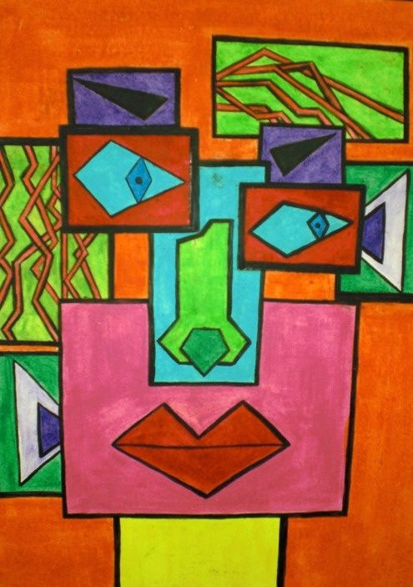**Who do we learn about in Art?**

We learn about famous Artists including:

* Vincent Van Gogh
* Pablo Picasso
* Andy Warhol
* David McEown
* Michael Kenna
* Monet
* William Morris
* Andy Goldsworthy
* Jackson Pollock
* L.S Lowry

**SMSC**

Spiritual development in Art

Pupils have opportunities to communicate their ideas, meanings and feelings. Pupils use their imagination and creativity. Pupils will investigate visual, tactile and other sensory qualities of their own and the work of others. Pupils will develop independent thinking and develop their ideas.

Moral development in Art

Pupils will talk about how artists and designers represent moral issues.

Social Development in Art

Pupils work is celebrated by sharing with other classes and working collaboratively on Art projects. Recognise the need to consider the views of others. Respect each other’s ideas and opinions.

Cultural Development in Art

Pupils will develop knowledge and understanding of artists’ ideas and concepts identifying how meanings are conveyed. Pupils will learn about Art from around the world and how these present the variety of cultures.

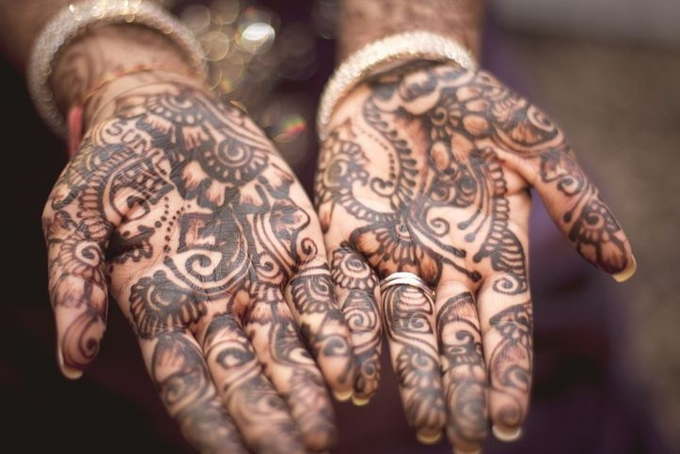

**Art takes pupils to other worlds, cultures and times, as they explore ideas in the work of a variety of artists.**

**Impact**

Assessment and feedback to pupils is usually carried out by observation and oral feedback during lessons. Children are encouraged to reflect on their work as it progresses, and evaluate their finished piece. Children’s individual sketchbooks are a key source for the assessment of pupils and the progress they have made. Subject leaders are continuously monitoring their subject to ensure that it meets the needs of our pupils. Senior Leaders also monitor each curriculum subject. This is done through:

* Learning walks
* Book scrutiny
* Lesson observations
* Pupil surveys and discussions/Pupil Voice
* Staff surveys and discussions.

The class teacher is responsible for assessing all areas of Art and logging the progress of each child using O-Track to assess against each of the objectives taught.

**Role of the co-ordinator**

* Develop Art and Design within the school.
* Monitor the standards of teaching and achievement of skills.
* Establish high expectations for all pupils and ensure their consistent achievement.
* Provide support to staff.
* Audit resources on an annual basis and replenish as necessary.
* Attend courses and pass on any new subject developments to teaching staff (Including HPAN Art Development day)

**Resources**

There are a wide range of resources available for staff to use to teach Art. Classrooms have a range of basic resources, but the majority of Art resources are stored in the Art cupboard as well as the resource room. New resources are purchased at the end of the academic year (July). Any extra resources are ordered and purchased throughout the year when needed.

**Art co-ordinator:** Jenny de-Beger

**Policy Updated:** September 2023

**Policy Review Date:** September 2025

|  |  |  |  |  |  |  |
| --- | --- | --- | --- | --- | --- | --- |
| **2023-2024** | **Autumn 1** | **Autumn 2** | **Spring 1** | **Spring 2** | **Summer 1** | **Summer 2** |
| **Reception** | So Much  The Leaf Thief  Drawing skills  Draw a self portrait  Draw me and my family | The Jolly Postman  Stickman  The Nativity  Collage of Stickman | Whatever Next  HPAN artwork | LRRH  The Three Little Pigs | The Caterpillar  What the Ladybird Heard | The Naughty Bus  Rainbow Fish  Rainbow fish collage using tissue paper |
| **Year 1** | Unity in the Community  Sketch their way to school from their house. | The Beatles | Building Bridges  HPAN artwork | Rainforest  Rainforest animal. Pop art (oil pastels). Artist Andy Warhol | The Arctic  Paint an Arctic landscape. Artist David McEown | Royal Patrons (The Queen) |
| **Year 2** | NESW  Sketching landscapes/local area sketch  Artist Michael Kenna | Remember Remember | Africa  Painting African patterns (dot art)  HPAN artwork | Africa  Painting an African mask | I do Like To Be Beside the Seaside | The Great Fire of London |
| **Year 3** | Journey to Greece | Three Giant Steps (Dover, France and Canada) | The Stone Age  *Cave Paintings  HPAN artwork | Victorians  Artwork inspired by Monet using pastels to create their own scene | Victorians  Study of William Morris. Victorian silhouettes using charcoal | Rainforests of SE Asia  Painting canopies and native animals in their habitat |
| **Year 4** | Lightning Speed | Visit the Mediterranean | The Romans  Create a Roman mosaic using clay  HPAN artwork | The Romans | The Saxon King  Bayeux Tapestry scene using water colours | Brazil vs Scotland  Sculpture of Christ the Redeemer statue |
| **Year 5** | Mission Control Earth and Beyond  Moon/planets artwork using graphite and chalk | WW2 | In Your Element. Earth, Air, Fire, Water  HPAN artwork |  | The Egyptians  Sarcophagus, jewellery and clay Canopic jars. | North America  Painting with a focus on the artist Jackson Pollock. |
| **Year 6** | Industrial Revolution  Industrial scene inspired by British artist L.S Lowry using water colours | Survivor | South/Central America  HPAN artwork | South/Central America  Using clay to create a Mayan iconograph | The Vikings | Global Warming  Sculpture using recycled materials |

**Appendix 1**

**Art and Design Topic Overview**