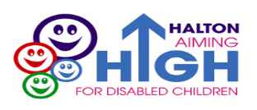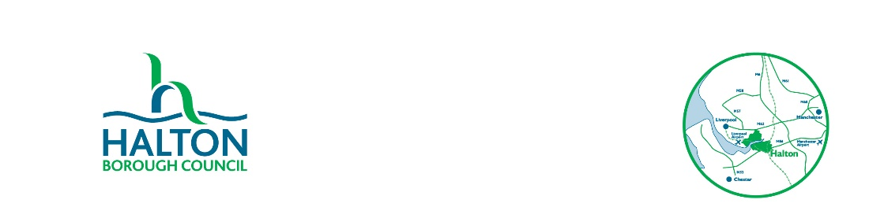**Short Breaks Service**

**For Children with Disabilities**

**Newsletter w/c 19 February 2024**

This newsletter contains events and updates from various services around Halton, as well as other general information which you may find useful. You can find out more information on the [**Halton Local Offer page online**](https://localoffer.haltonchildrenstrust.co.uk/) or contact the[**Short Breaks Service for Children with Disabilities**](mailto:aiminghigh.fordisabledchildren@halton.gov.uk)teamtoo.

**Ice Cream Farm SEN Sessions**

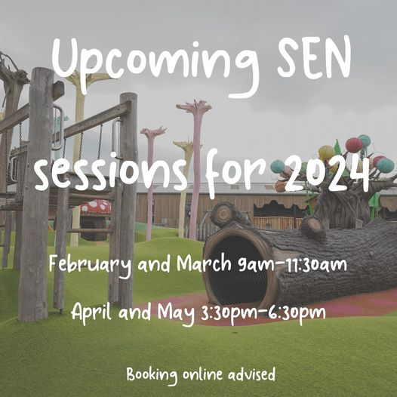

**To book a p**

**Morning Sessions (9 am - 11:30 am):**

* Sunday 11th February
* Sunday 24th March

**Afternoon Sessions (3:30 pm - 6:30 pm):**

* Sunday 21st April
* Sunday 19th May

All dates are avaialbe to book using this link;[Checkout (roller.app)](https://checkout.roller.app/theicecreamfarm/products/booknow#/sessions)

**Halton SEND Parent Carer’s Forum Parent Check-In**

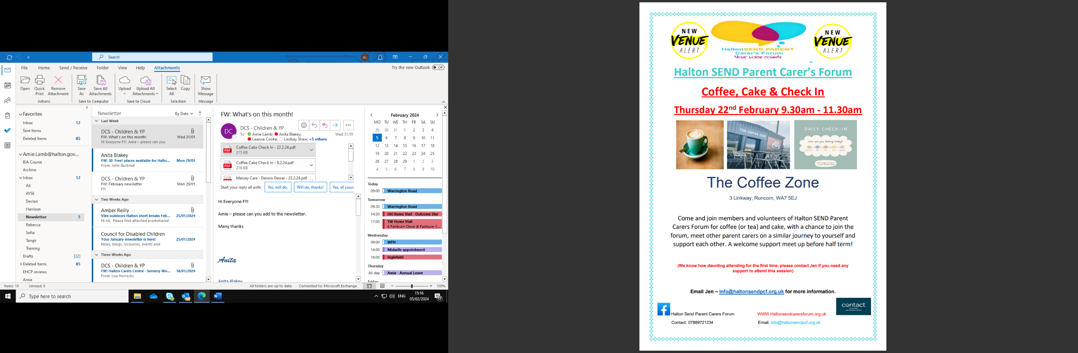

Email Jen at [info@haltonsendpcf.org.uk](mailto:info@haltonsendpcf.org.uk) for more informati

**Halton Carers Centre Sensory Workshop for Parent Carers**

Places are £5 each

Scan the QR code to be added to the interest list

**Free Family Craft & Pizza Night**

Email Clare.Collins@haltonsendpcf.org.uk

**Vibe Youth Club for Children age 11-19**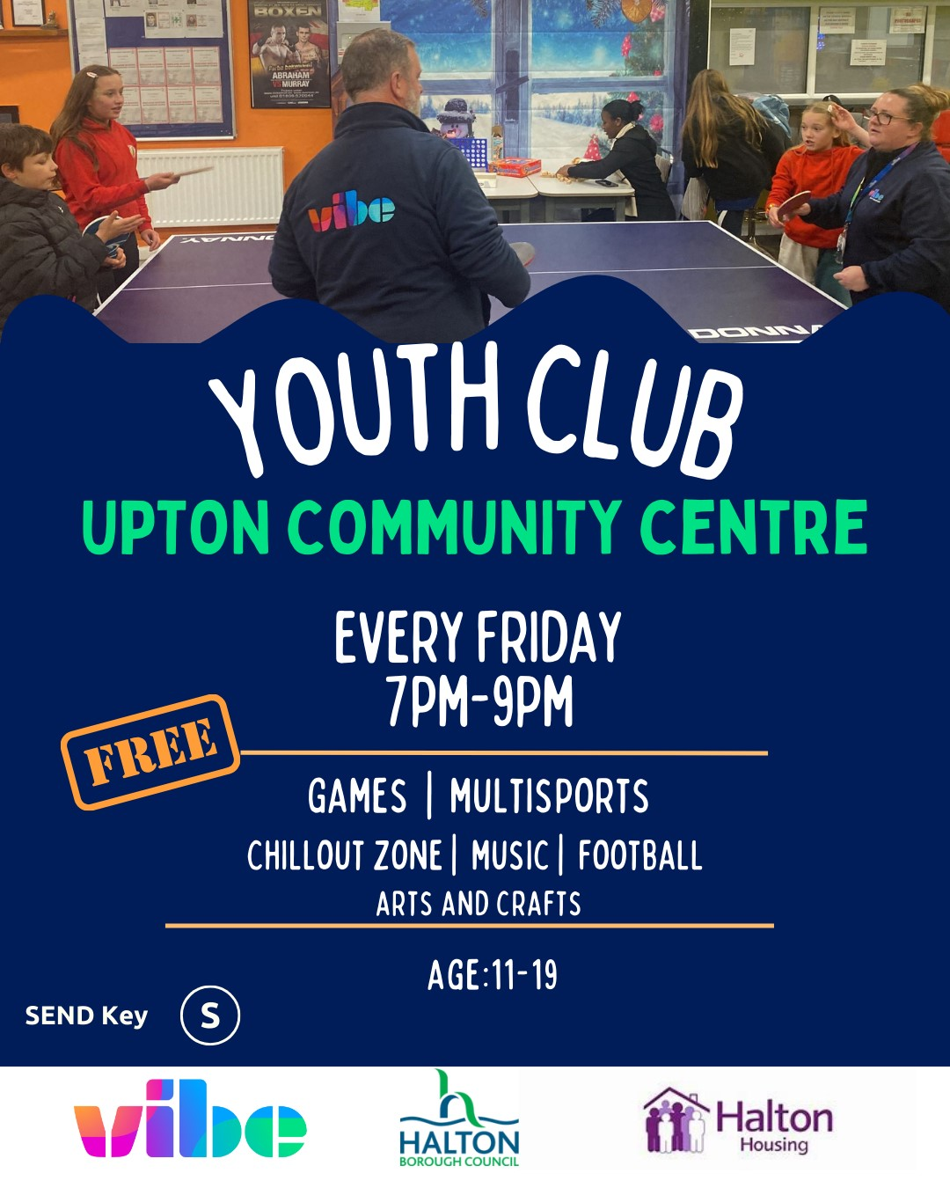

**Accessing Short Breaks information on the Halton Local Offer**

[](https://localoffer.haltonchildrenstrust.co.uk/)

](https://localoffer.haltonchildrenstrust.co.uk/halton-children-family-services/halton-short-breaks/)

Don’t forget you can access our Short Breaks page on the Local Offer by scanning this QR code here or [**click this link**](https://localoffer.haltonchildrenstrust.co.uk/halton-children-family-services/halton-short-breaks/).

Here you’ll find lots of useful information and resources, while [**the Leisure page here**](https://localoffer.haltonchildrenstrust.co.uk/leisure/) has details of activities and events across Widnes and Runcorn

And your feedback and suggestions help us to keep improving the Halton Local Offer for families across our borough – [**click here to share your feedback**](https://halton.me/local-offer-contact-us/)**!**

**MAX cards**

Autism Central Hubs offer guidance to families, carers and personal assistants of autistic people. All of their sessions are run by Peer Educators who are parents or carers of autistic people, who are happy to share their knowledge and experience with you.

Don’t forget that Max Cards are available for our families in Halton all year round.

The card is designed to help families save money on great days out at castles, zoos, bowling alleys and more.

[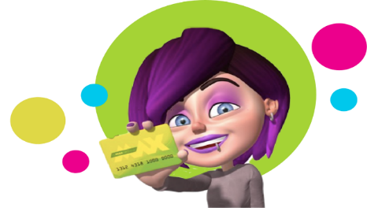](https://mymaxcard.co.uk/)

You can visit the [**MAX Card website**](https://mymaxcard.co.uk/) for further details or check out [**the Local Offer**](https://localoffer.haltonchildrenstrust.co.uk/halton-children-family-services/halton-short-breaks/). Cards cost £2.50 and can be collected from Warrington Road Children’s Centre in Widnes, or Glendale Family Centre in Runcorn (available Monday to Friday 9am to 4.30pm – please note, it is cash payments only).

You can email [**AimingHigh.forDisabledChildren@halton.gov.uk**](mailto:AimingHigh.forDisabledChildren@halton.gov.uk) or call 0151 511 6560 for more details.

This newsletter provides general information and resources for parents and carers of young people with SEND, and for professionals who support them. Please note, while we take every care to ensure the information, we share is accurate, the information provided is not a direct recommendation from the Short Breaks Service and we recommend that you complete your own research about the information and events we signpost.

We recognize that not all the information in this newsletter will be relevant to everyone included on the mailing list. If there is some specific information you would like to see more of, or information from a certain service that you’d like to share please let the Short Breaks Service know and we will try to include it next time. If you do not wish to continue receiving this newsletter, please let us know by contacting us at the email address or phone number below.

**Halton Borough Council**

**Short Breaks Service for Children with Disabilities**

Email: [**AimingHigh.forDisabledChildren@halton.gov.uk**](mailto:AimingHigh.forDisabledChildren@halton.gov.uk)

Tel: **0151 511 6560**