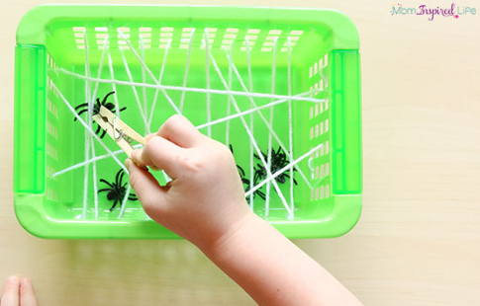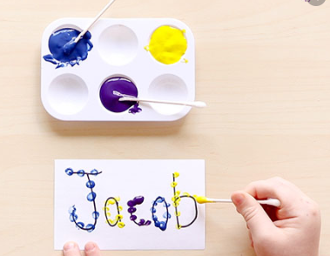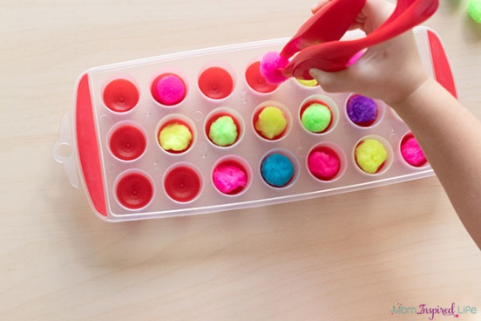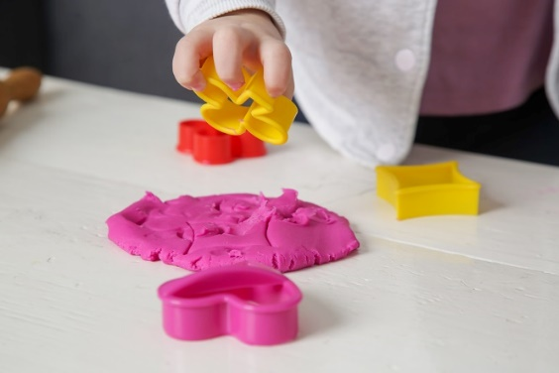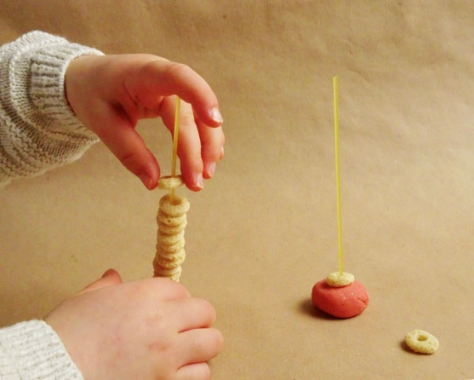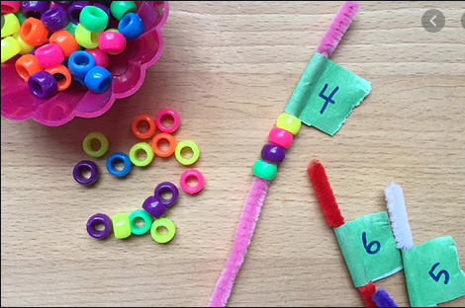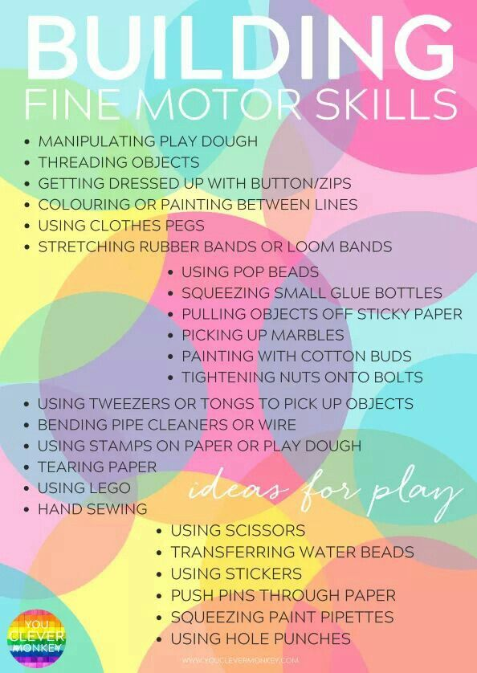

Fine motor skills start to develop when a child uses the smaller muscles in their hands, wrists, fingers, feet and toes. Developing those muscles includes actions like grasping, holding, pressing, or using a pincer grip (holding something between the fore-finger and thumb).  Developing this is very important and must be considered before beginning to write too soon.