
Parish of St Wilfrid
Lent 2025

Ash Wednesday – 5th March
7am – Holy Mass at St. Bede
9.30am – Holy Mass at St. Basil
12noon – Holy Mass at St. Michael
7pm – Holy Mass at St. John Fisher

Scripture Group – Jubilee of Hope
Tuesday 11th March
Tuesday 18th March
Tuesday 25th March
Tuesday 1st April
Tuesday 8th April
Tuesday 15th April

These sharing sessions on the Scriptures will take place after the 12noon Mass at St. John Fisher and will be led by Anne Skilki.
Come along, it is a beautiful way to know who Jesus is!

Taize Prayer – ‘All who are thirsty…come’
Tuesday 11th March at 7pm at St. Basil
Led by the Music Ministry at St. Basil

Early Riser Mass at 7am
Wednesday 12th March
Wednesday 19th March
Wednesday 26th March
Wednesday 2nd April
Wednesday 9th April
These will take place at St. John Fisher

Holy Hours during Lent
Monday 17th March at St. John Fisher – Jesus, the Healer
Monday 31st March at St. Basil – Jesus, the Word Made Flesh
Monday 7th April at St. Michael – Jesus, the Comforter
These Holy Hours will be led by our Clergy Team and will start at 7pm.

CAFOD – Soup and Prayer
Thursday 10th April, 7pm at St. John Fisher Hall

Lenten Confessions
Saturday 12th April at 10am at St. Basil

Lenten Reconciliation Service
Tuesday 15th April at 7pm at St. John Fisher

Stations of the Cross
Monday 10th March at 7pm at St. Basil
Monday 14th April at 7pm at St. John Fisher

Walk of Witness – Palm Sunday, Sunday 13th April
3pm starting at St. Bede, walking through Victoria Park

Easter Lilies
Would you like to buy a lily for Easter? These flowers are often bought in memory of a loved one and their names are displayed in each of the Churches for the Sacred Triduum and Easter Sunday. There will be envelopes and forms at the back of all churches that should be completed and returned to the Parish Office before Friday 11th April. A lily is £5 each.

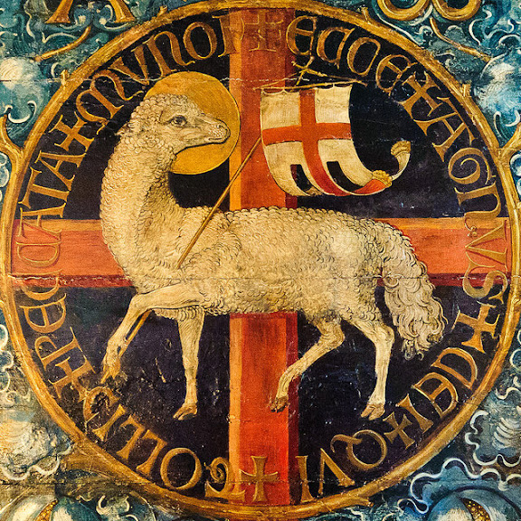

TRIDUUM
Maundy Thursday – 17th April
7pm – Mass of the Lord’s Supper at St. Michael
8pm – 8.45pm – Watching in the Garden of Gethsemane
8.45pm – Night Prayer

Good Friday – 18th April
11am – Children’s Stations of the Cross at St. John Fisher
3pm – Passion of Our Lord and Veneration of the Cross
St. Bede and St. Michael

Holy Saturday – 19th April
8.30pm – Vigil of the Resurrection at St. Michael

Easter Sunday – 20th April
9am – St. John Fisher
9am – St. Basil
10.15am – St. Michael
10.30am – St. Bede

