LO : to identify the global pattern of climatic zones
Colour in the different climatic zones. Use this key:
Arctic = light blue Temperate = light green Mediterranean = pink Desert = orange Tropical = purple
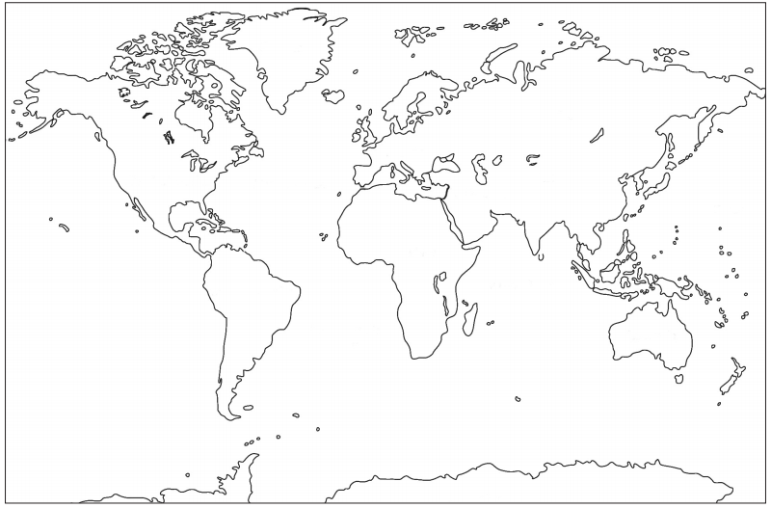
Fill in this table with information about the different climatic zones :
 | Arctic | Temperate | Mediterranean | Desert | Tropical
Temperature :
What is winter like?
What is summer like?
What lives in this climate?
Places with this climate :

Use information from :
http://www.bbc.co.uk/learningzone/clips/climate-zones-across-the-globe/11182.html http://www.tes.co.uk/teaching-resource/Teachers-TV-Weather-Around-the-World-6047845/

