

OPAL NEWSLETTER
Autumn update

Dear Parents/Carers.
Welcome to our Autumn OPAL newsletter. The Autumn term has been full of fun so far and there is even more to come!

Benefits of OPAL PLAY:
Tesco Blue Token Scheme:

We are thrilled to share the wonderful news that our school was victorious in the Widnes Tesco Blue Token Scheme and we were awarded £1,500 in July.
This achievement wouldn’t have been possible without the incredible efforts of everyone who collected tokens and voted on our behalf.
Thank you to Mrs Heston who nominated our school.

The past year has been a fantastic chapter for our OPAL initiative. As our play provision has evolved and expanded, it has fostered an environment where children are inspired to engage creatively and meaningfully with a diverse array of resources and thoughtfully designed zones. This progression has not only enriched their play experiences but has also played a pivotal role in their broader personal development.
Looking ahead
As OPAL continues to evolve, the focus remains on refining and expanding these play opportunities to support children's active learning and well-being. This success story highlights the profound benefits of investing in thoughtfully designed play spaces—reminding us that when children are given the freedom and encouragement to explore creatively, they flourish not only as learners but also as confident individuals.

What we’ve introduced-
OPAL afterschool club
This autumn, we proudly introduced our first OPAL afterschool club to our KS2 children. The response has been overwhelmingly positive, in fact, the club was so heavily oversubscribed that we are excited to announce the launch of a second session in the upcoming spring term.
In our first session we explored our artistic sides, using acrylic paints to create unique stone art pieces. Decorating fairy houses, whimsical toadstools, and delicate ceramic fairy models added a touch of enchantment, all destined to enrich a fairy garden in our woodland area.
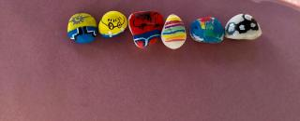
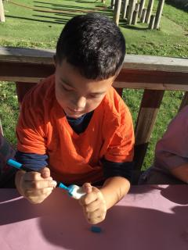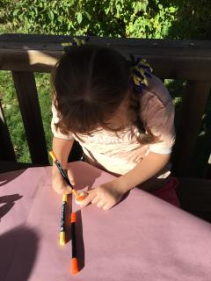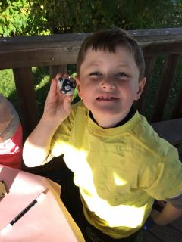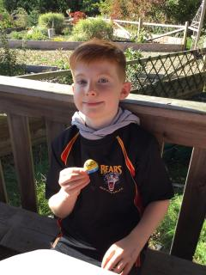
Preparing for the change in the weather
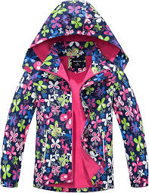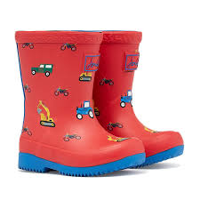
As the seasons shift from the unpredictable mix of September and October into the colder, wetter months ahead, children will continue to play outside during playtime and lunchtimes in all kinds of weather. It requires careful preparation to keep them safe, warm, and dry throughout the school day.
With the weather capable of changing rapidly, it is essential that every child comes to school every day equipped with a suitable coat—ideally a waterproof one. Additionally, a spare pair of socks is highly recommended. Outdoor play areas such as the field, sandpit, and the woods can become muddy and wet.
A particular important item for outdoor play is wellies they are crucial for safe access to the more natural, potentially muddy zones within our school grounds.

Following the art session, we split into small groups to build dens within the Woods Zone. This activity enhanced our collaborative skills and allowed us to engage actively with nature.
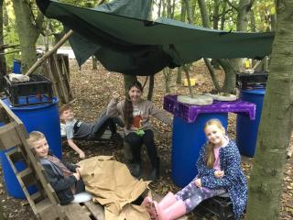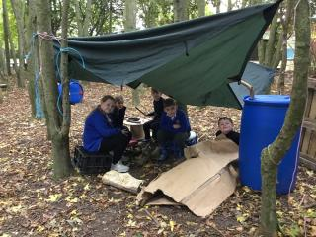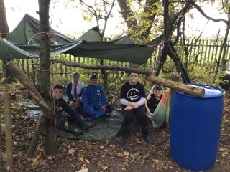
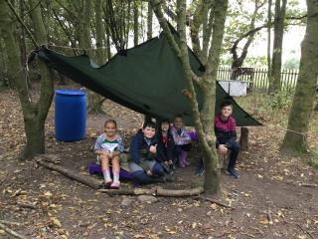
Then, using gardening gloves, trowels and forks, we worked to clear weeds and leaves from planters, preparing them for upcoming planting.
Next as the weather outside changed, we took our fun orienteering activity inside. The children worked together using a map key and equipment, to create Funny Faces through map-based clues.
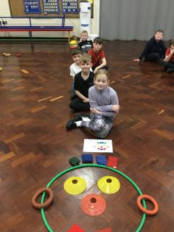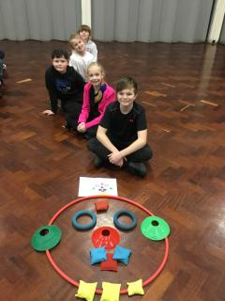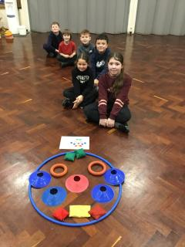
In our last outdoor session, we explored the art of crafting clay faces using materials found directly within the Woods Zone. This hands-on activity blended creativity with nature, allowed the children to engage with their natural surroundings while making sculptures.
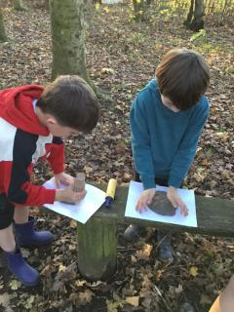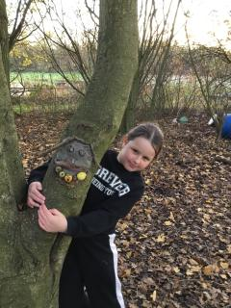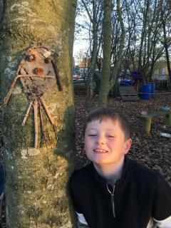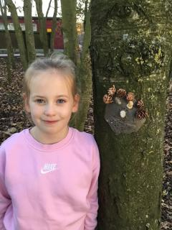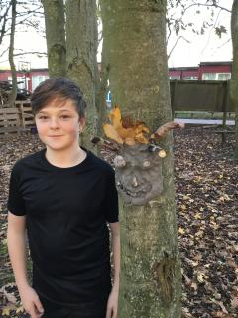
What we’re introducing next:
A Digging zone- ‘Mud Marvellous Mud’

We are thrilled to announce a series of exciting projects planned for the coming months, designed to enrich the play experience and foster creativity among our children.

One of those projects is the creation of a new Digging Zone on the field area. A hands-on, interactive space where our children can use a variety of tools and materials to dig, build, and experiment offering them a stimulating environment. In the next few weeks, work will commence to prepare the area.

How You Can Help
To bring this vision to life, we are inviting volunteers to lend a hand during the preparation and digging phases. A letter has already been sent inviting those interested to help, and we warmly encourage anyone able to contribute some time if you can pop into the office and leave your details. The more helpers we have, the faster the project can progress, and the sooner children will be able to enjoy this exciting new space.

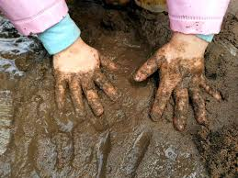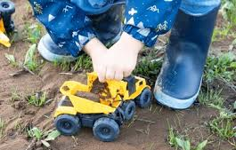

Water Zone-:
We are planning to implement a water zone over the next few months see below for donations needed. -
Watering cans Funnels Rollers
Measuring jugs Paint brushes Sieves
Sponges Colanders Plastic cups

OPAL Loose parts Bingo
Over the months of January and February, we will embark on an exciting whole-school game of OPAL Loose Parts Bingo, designed to resource our newly developing digging and water zones. The focus will be items from the above zones which are designed outdoor spaces where physical activity meets sensory exploration plus items for our existing zones.
More details to follow after Christmas.

Thank you!
As we approach the festive season, it feels timely to express our thanks to everyone who has continued to support OPAL throughout the past year. Your donations and goodwill have been instrumental in advancing our OPAL vision.

As Christmas draws near, many of us find ourselves clearing out our homes in anticipation of the new year. That simple act—of sorting through items and deciding what to keep, donate, or let go—can become a perfect opportunity to support OPAL. By sharing your resources, you enable OPAL to continue making an impact—and for that, we are incredibly grateful.

How can you help?

We would really appreciate any of the following:
- Spades, trowels, gardening gloves
- Funnels, watering cans, measuring jugs.
- Children clothes for role play normal clothes and performing items, feather boas etc
- Digger trucks
- Dinosaurs, action figures, farm animals
- Dolls, dolls clothes, dolls prams
- Scooters or any other wheeled items (prams, trollies, etc)
- Waterproof fabric/ shower curtains, tarpaulin for den building



