


OPAL NEWSLETTER
Spring update

Dear Parents/Carers.
Welcome to our Spring OPAL newsletter. Hooray! Fortunately, the rain is drying up and we can now revel in the beautiful dry weather and make the most of the field.
Benefits of OPAL PLAY:
The last few months of OPAL play, has been amazing. Our play provision is evolving and getting better. The children have made the most of what OPAL play has to offer despite the fluctuating weather.
It has been wonderful to observe the children having fun, being inspired and motivated to play with different resources and in different zones.

What we’ve introduced:
Mud kitchen:
After February half term we opened our Mud Kitchen (located in the woods near the back fence) which has been a great success! The children have been busy cooking up a feast, making different recipes mud pies, pine cones stews and leaf salads. A huge thank you to Mr Daniels for all your hard work. Thank you for all the resources donated in the OPAL Bingo.
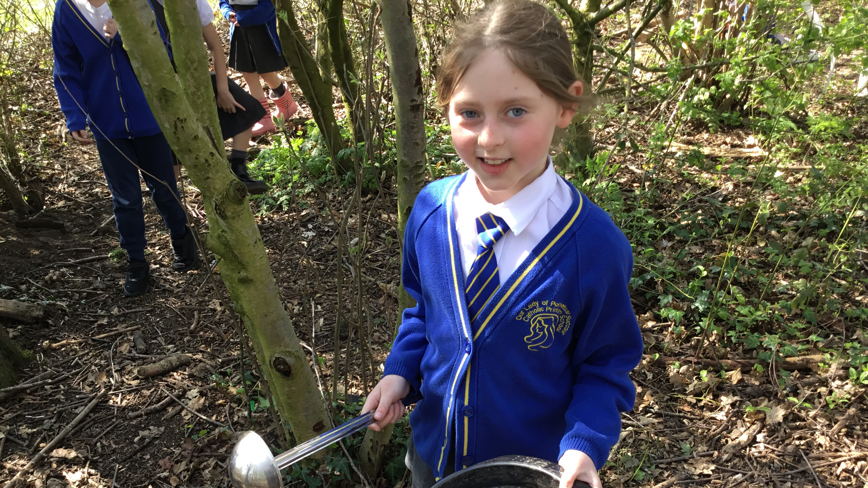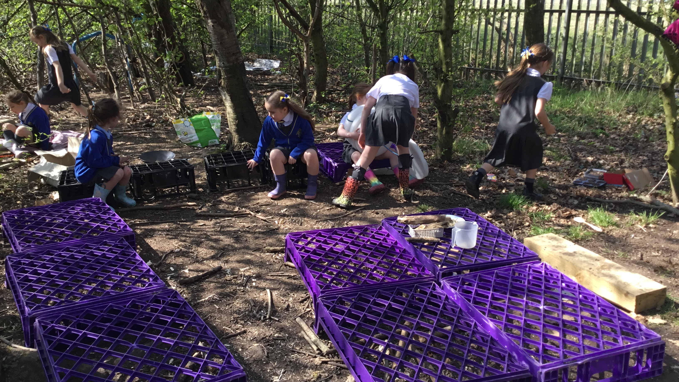

Den building:
We have also introduced a Den Building Zone in our woods. Den building is a key element of OPAL, promoting; creativity and imagination, problem-solving, teamwork and cooperation and physical activity.

We have provided a variety of materials- loose parts natural and man-made objects that can be used in various ways, such as branches, twigs, fabric tarpaulin cardboard boxes and crates: These offer readily available structures for den building.

What is happening:
Sand Pit:
As you may be aware, work has started on our sand pit. Mr Daniels has been working tirelessly digging and preparing the area. We can’t wait to have lots of fun at the grand opening! More details to follow…

Tesco Blue Token Scheme:
We have been selected as one of the three good causes, to be in the customer vote, currently in the Widnes Tesco store. If you shop there please, ask for a few tokens and vote of our school as ‘Every little helps.’ We will use the money to further enhance OPAL.

PexHill JFC- Thankyou to PexHill JFC for their kind donation of a football net.

Water Zone-:
We are planning to implement a water zone over the next few weeks see below for donations needed.-
Watering cans Funnels Rollers
Measuring jugs Paint brushes Sieves
Sponges Colander Plastic cups

Stay and Play:
This term we are holding our first whole school stay and play sessions; where parents were invited to stay and play in the morning and afternoon to experience your children’s current play time. Below are the times for the sessions;
Tuesday 20th May
A.m. session 9.15 a.m.- 9.45 a.m.
P.m. session 2.15 p.m.- 2.45 p.m.
How you can help?
We would really appreciate any of the following:
- Toy cars, trucks
- Dinosaurs, action figures, farm animals
- Dolls, prams
- Role play toys such as play kitchen equipment, play mechanic/ builder, etc
- Scooters or any other wheeled items (prams, trollies, etc)
- Blankets, shower curtains, fabrics for den building

As always, we are grateful for all donations.


Let’s keep working together to create incredible experiences for our children and continue to make play fun.

