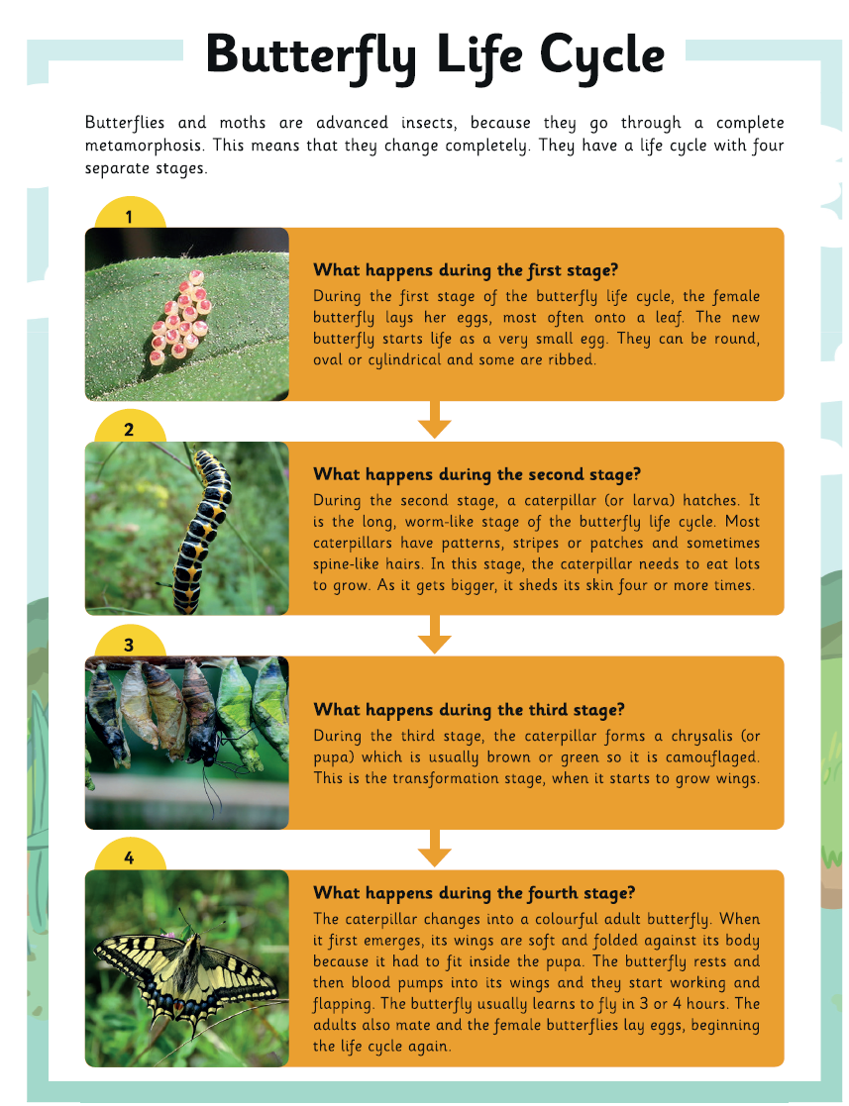
Questions about the Butterfly Cycle

- How many stages are there in a butterfly’s life cycle?
____________________________________________________________________________________________________________________________________________________________
- What shape can the butterfly eggs be? ______________________________________________________________________________________________________________________________________________________
- What hatches in the second stage?
______________________________________________________________________________________________________________________________________________________
- What do caterpillars look like?
_____________________________________________________________________________________________________________________________________________________
- What happens to the caterpillar’s skin?
______________________________________________________________________________________________________________________________________________________
- What colour is the chrysalis (or pupa)?
____________________________________________________________________________________________________________________________________________________________

- What does it grow during the pupa stage, before it becomes a butterfly?

_____________________________________________________________________________________________________________________________________________________
- What does the caterpillar change into?
______________________________________________________________________________________________________________________________________________________
- How long does it usually take the butterfly to learn how to fly?

______________________________________________________________________________________________________________________________________________________

