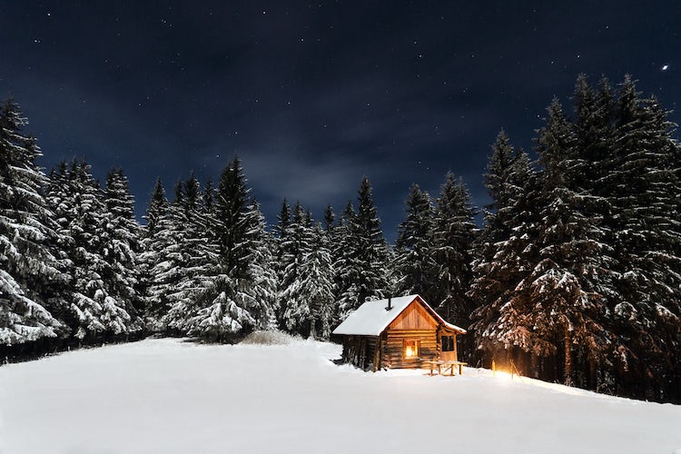

Silence. The silence was ear splitting! I was alone - alone and cold but there in the distance I could see a light. A beacon of hope; a chance of warmth. The inky black sky was peppered with diamonds shining on the white icing-sugar mounds below. The giants stood guarding the place of safety, dusted in shimmering crystals of snow and ice. Suddenly, dancing in the sky I could see swathes of green, blue and indigo – the Northern Lights! Wow! My heart soared. This was a sight I had hoped to see on my visit to the Norway and here they were – just for me – dancing and swirling and performing their wonderful show even though nobody else was there.
Norway had been a nightmare. It had begun twenty-four hours ago when they had lost my luggage at the airport and later when I had lost the group I was travelling with and ended up alone in the forest. Anyway, I would head to the light, the wooden chalet in the distance – surely, there would be somebody who could help me?
As I began to walk towards the shimmering golden light, the silence disappeared and was replaced with the sound of crunching as my feet trudged through the deep, bitterly cold snow. This place was beautiful but colder than a freezer. I don’t think I had ever been this cold before in my life. I began to shiver and tried to walk quicker but the snow was deep and impossible to move through at speed. Just when I thought things could not get any worse, the snow began to fall. Silently and gracefully, it tipped down from the dark sky landing on everything in sight – including me! However, I was there, I had reached the place of safety. I took the final step, knocked on the door, and waited.
Nothing – just the sound of my breathing, heavy and fast. Then it opened with a creak. “Hello I was wondering if you could help me?” my hollow voice whispered.
“Of course, come on in,” replied a deep voice from behind the wooden entry point. My heart pounded in my chest. Should I go in? What choice did I have?....

