Our Lady of Perpetual Succour Catholic Primary

Writing Policy

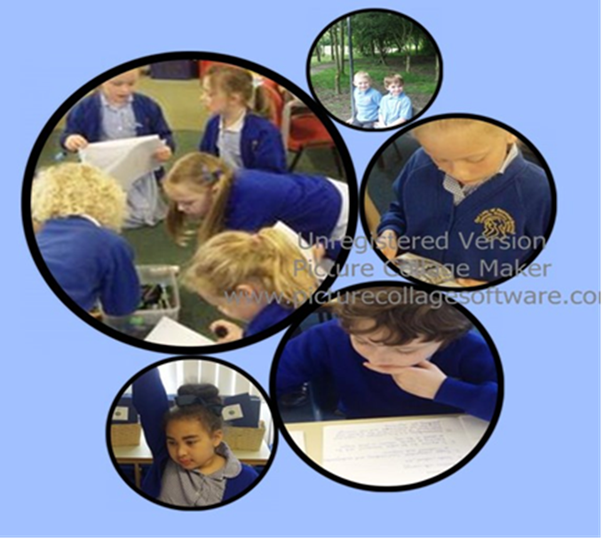

“We learn to love everyone as Jesus loves us”

“I’ll call for pen and ink, and write my mind.”

William Shakespeare

Introduction

The current education system places ever - increasing demands on our children. In view of the changes they face and an expectation for all pupils to be challenged to attain at, or above the ‘expected standard’, a new policy has been devised to address the needs of our teaching and learning.

At Our Lady’s, we believe that the ability to write with confidence and accuracy is an essential life skill. Writing is a complex process that draws upon more than handwriting and spelling. It is the ability to effectively communicate ideas, information and opinions through the printed word in a wide range of contexts. Successful writers understand the social function and characteristics of writing in order to use different genres appropriately, matching it to audience and purpose. Writing also requires the writer to understand and accurately apply the conventions of syntax, spelling and punctuation. We aim to equip children with the skills necessary to achieve this, throughout the curriculum.

Aims

Our aims are for all children at Our Lady’s to:

- Write with confidence, clarity and imagination;
- Understand and apply their knowledge of phonics and spelling;
- Understand how to write in a range of genres (including fiction, non-fiction and poetry), using the appropriate style, structure and features;
- Plan, draft, revise and edit their own work, and learn how to self- and peer-assess against the success criteria;
- Develop a technical vocabulary through which to understand and discuss their writing;
- Develop their imagination, creativity, expressive language and critical awareness through their writing.

We aim to develop, through our teaching of writing, the following attitudes:

- Curiosity and interest;
- Pleasure and thoughtfulness;
- Critical appraisal;
- Independence;
- Confidence;
- Perseverance;
- Imagination.

Implementation

At the moment, the government divides writing into two main strands:

- Transcription (that is the technical aspects of writing – Spelling, punctuation, grammar and handwriting.)
- Composition ( text and sentence structure, composition and effect)

At Our Lady’s we endeavour to teach writing through both discrete and embedded, cohesive, ways.

Writing is taught and celebrated in a range of ways, and is taught daily across the school across a range of subjects. We aim, wherever possible, to create cross-curricular writing opportunities, as we believe that in order for children to see themselves as successful writers they need to be involved in writing for a purpose. We aim to ensure there is a balance between cross-curricular writing as well as writing inspired by quality literature being read and studied.

We follow the revised National Curriculum, which ensures that a range of genres are covered, including narrative (e.g. extended stories, stories by the same author, myths and legends, adventure stories and traditional stories), non-fiction (e.g. persuasive texts, non-chronological reports, information texts, recounts, reports and letters) and poetry (e.g. rhyme, nonsense rhymes, shape poems, acrostic and descriptive poetry). Genres are taught and learnt considering the:

- purpose
- form
- audience

Throughout each unit, the links between reading and writing are made explicit – we read as writers and we write as readers.
Teaching units provided from ‘The Power of Reading’ project are used alongside poetry and non-fiction books that complement other areas of the curriculum. In KS1, we will continue to follow the ‘Read, Write, Inc.’ scheme.
We strongly advocate the use of high quality literature as models of writing to study as well as sources of inspiration and engagement. We use the following structure for the learning journey:

1. Stimulate and generate (Power of Reading, ‘Read, Write, Inc.’, Learning Challenge, Pobble etc.)

⬇

2. Capture, sift and sort. ( Modelled, shared, guided and independent tasks.)

⬇

3. Create, refine and evaluate

Throughout the learning journey we plan opportunities for children to carry out practice pieces and to carry out self and peer assessment. There will be lots of reference to the Working Walls, within the Literacy lessons, as well as use of I-pads, visualizers etc, to draw attention to best practice and common errors. This is to happen across the curriculum AS WELL AS in English lessons, allowing the children opportunities to apply their previously learnt skills in other contexts, such as Topic, Science or RE.

Integral to the process of writing is speaking and listening. ‘Talk for writing’ is essential to enable children to articulate their thoughts, retell stories, orally create new stories and orally rehearse what they are going to write and re-read what they have written. This underlines and runs alongside the writing process. New technologies are being used to record and benefit from group discussions

Good writers:
- enjoy writing and find the process creative, enriching and fulfilling;
- read widely, recognise good writing, and understand what makes it good;
- are aware of the key features of different genres and text types;
- learn about the skills of writing from their reading and draw (consciously or unconsciously) upon its models in their own work
- have ‘something to say’ (a purpose) and know how to say it for the specific audience;
- know how to develop their ideas;
- know how to plan and prepare for writing;
- make informed choices about what they are writing, as they write (for example, about vocabulary, grammar, text structure, etc.);
- understand how to reflect upon, refine and improve their own work;
- can respond to the constructive criticism of others.

Writing is taught in a range of ways. Research suggests that whenever possible, grammar and punctuation are best taught when they relate to books and subjects being studied, rather that isolated, paper exercises. Therefore, at Our Lady’s we create grammar and punctuation lessons, which relate to literature (Power of Reading texts,) and/or subjects being studied, (Eg.The Romans), whenever possible.
Staff also use the ‘Primary Spelling, Punctuation and Grammar’ scheme to support understanding and practice of the skills required for each year group.

Modelling Writing
The teacher talks aloud the thought processes as a writer. They model strategies in front of the children, communicating the strategies being used. Teachers may model writing skills such as punctuation, rehearsal, proof reading, editing, word selection, sentence construction and paragraphing.

Shared Writing
This is a collaborative approach in which the pupils contribute their ideas and thoughts for the teacher to write. The teacher models and teaches specific writing skills and there is the opportunity for discussion to choose the most effective or suitable ideas. We take note of what Pie Corbett says: ‘If teacher’s are not regularly using shared writing, then they are not teaching writing.’

Supported Composition
The children work in pairs to provide the next sentence of the text. This may follow from the modelled or the shared writing process.

Guided Writing
The teacher or other adult works with the group on a carefully selected task appropriate to that group’s needs and targets. This will focus on a particular aspect of the writing process rather than writing a complete piece.

Independent Writing
Children are given opportunities to apply their understanding of a text type in their own writing. The usual practice is that children are encouraged to plan, draft, write, edit and assess their work: applying the skills they have learnt throughout the unit of work on that particular genre.
Children also have access to an electronic resource book called ‘Descriptosaurus’

Furthermore, we subscribe to ‘Pobble 365’, an on-line resource that provides inspiring lesson ideas, based around visual images, which also allows you to build an online evidence bank of pupils’ writing. There is also the opportunity to connect with classrooms around the world and publish the work of your pupils to a global audience – what a way to celebrate writing!
Pobble inspired work can be recorded in planning/draft books, or English books.

The teaching and learning of writing varies across the age range in school. In the early years emergent writing is encouraged through the use of different writing materials, including felt tipped pens, crayons, chalk, sand, magnetic letters, big brushes, water, paint and computers, as well as writing in the role-play areas, such as postcards, menus, invitations, labels etc. Alongside this, children take part in activities to encourage and develop gross and fine motor skills necessary to write in a legible script.

Daily phonics lessons build their phonic and spelling knowledge to enable them to sound out words and spell high frequency words correctly. This year we are able to embed ‘Read, Write, Inc.’ for a full year, which should further enhance reading and writing skills. Children throughout the year groups have spellings to learn relevant to their age, and these focus on high frequency words or a particular spelling pattern. (See spelling policy.)

As children progress throughout the school, they are given many opportunities to write independently and to apply the skills they have learnt and rehearsed in shared and guided writing. Wherever possible, writing is made meaningful by being planned for a specific purpose or in response to a particular experience.

Vocabulary, grammar and punctuation is planned and taught as an integral part of each unit of work; both discretely and implicitly. The objectives are carefully matched to the unit of work to enable them to be taught and learnt within a meaningful context.

Vocabulary
Due to the increased demands of recent reading tests, a concerted effort has to be made to address the acquisition of a varied, sophisticated vocabulary. Each classroom is to display interesting and stimulating vocabulary lists, which will encourage interaction and exploration. The ‘Word of the Week’ will be recorded in the children’s vocabulary books and built up on the working wall over time. These words can relate to topics being studied or from literature being read, and are ambitious for the children’s age, and are to be discussed throughout the week, referring to possible synonyms and antonyms, which can also be recorded in the children’s vocabulary books. The children are challenged and rewarded when they include them in their writing.

Role of Parents and Carers
Parents and carers are strongly encouraged to be actively involved in their children’s writing at all ages, by encouraging them to write for a range of purposes such as shopping lists, diaries, notes, letters, cards, stories etc. The use of Focus Education’s ‘Learning Challenges’ engage the pupils in independent writing opportunities that are set both at school and also for homework tasks.

Assessment and Record Keeping
Assessment is used to inform the planning and teaching of writing. We assess using the’O-track’ system to monitor progress:

- Transcription ( see separate spelling policy)
- Handwriting (see separate policy)
- Composition: Text and sentence structure and organisation
- Vocabulary, grammar and punctuation

Assessment against these criteria takes various formats:

- Regular pupil progress meetings: Writing is assessed against and tracked using ‘O-track’, (‘working towards’, ‘expected’, or ‘above’) and is sent home as part of the children’s reports;
- Success criteria created by the teacher and the children, which is used to self- and peer-assess;
- KS1 have regular, on-going phonics tracking assessment, in which children are assessed against the ‘Read, Write, Inc.’ scheme, and gaps in learning are identified;
- Regular SPaG assessments to ascertain gaps in learning;
- SATs Writing Assessment at the end of Key Stage One (Y2) and end of Key Stage Two (Y6), as well as optional SATs in Years 3 – 5;
- Half termly spelling tests from ‘Oxford Owl’ (see separate spelling policy.)

Equality
We aim to give all our pupils the opportunity to succeed and reach the highest level of personal achievement and to promote the individuality of all our pupils, irrespective of ethnicity, attainment, age, disability, gender or background.

All children have particular learning needs, including SEN and Gifted and the More Able. Progress is monitored continuously against the government requirements, both internally and externally with our colleagues from local primary schools. Writing support is carefully chosen to meet the needs of all children, particularly those who need extra support or challenge. These include 1:1 sessions, small writing groups and phonics intervention groups. Extra resources may also be used, such as scaffolded writing frames and apps and devices for recording on I-pads, for children to verbally record their sentences before writing.

Monitoring of the Policy

We are aware of the need to monitor and update the school's Writing Policy on a regular basis, so that we can take account of improvements made in our practice, and changes to assessments, materials and government requirements. We will therefore review this policy annually. The member of staff with responsibility for writing is the Literacy Leader – Mrs Richardson-Hignett.

Writing throughout the school and how it reflects this policy will also be reviewed throughout the year in the following ways:

- Governor’s work scrutiny;
- SLT/English Co-ordinator/staff work scrutiny;
- EYFS/KS1/KS2 external moderation;
- EYFS/KS1/KS2 internal moderation;
- Moderation with other schools;
- Learning walks.

Policy Adopted by Governors

SIGNATURE:

DATE:

Date: September 2019

Policy Adopted by Staff

SIGNATURE:

DATE:

Date for next review: September 2020

