How to make an African Maasai necklace
First click on the link below and watch the video of how to make an African Maasai necklace
https://www.youtube.com/watch?v=yfzXIY2zCIE

Next here are instructions try for yourself :)

- Start off with a paper plate. Ask an adult to help cut a “v” shape out of the top of the plate. Then cut along the inside circle.

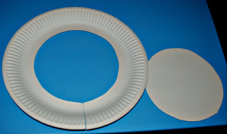

- You can colour or paint in bright and fun African colours and designs on the paper plate

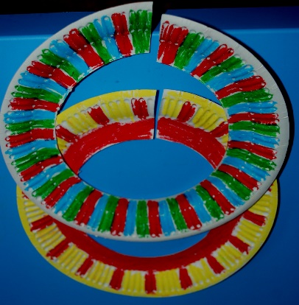

- You can glue buttons, beads sequins or even pasta on to decorate.
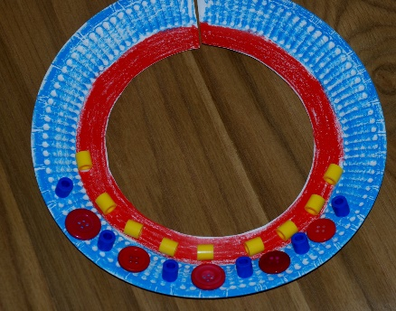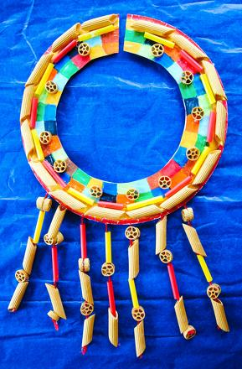
- Wear the necklace proudly and send me a picture!

