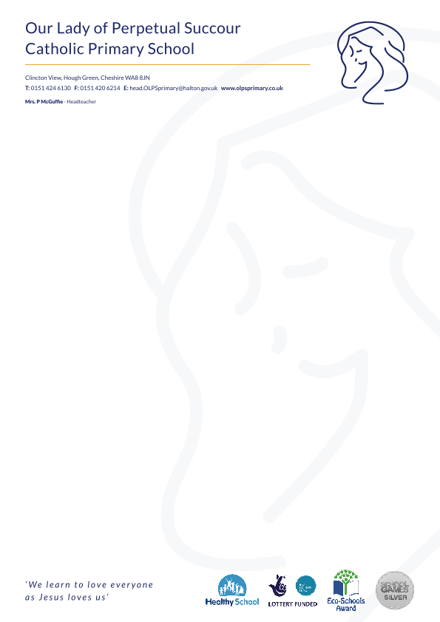

**Welcome to   
Our Lady of Perpetual Succour Catholic Primary School**

**Information booklet for Reception parents**



***We learn to love everyone as Jesus loves us.***

**Key Staff**

* Mrs McGuffie – Head teacher
* Mrs Donnelly – Deputy Head teacher
* Mrs Heston – SENCo (Special Educational Needs Co-ordinator)
* Mrs Stanley - Office Manager

**Reception Teachers**

* Miss Beger – Reception Teacher
* Miss Downey – Teaching Assistant

**Staff at Our Ladys**

Mrs McGuffie - Headteacher

Mrs Donnelly – Deputy Headteacher

Miss Beger – Reception teacher

Miss Downey – Reception teaching assistant

Miss Bennett – Teaching assistant

Mrs Stanley - Office Manager

**Our aim for when your child starts school**

* To become settled in their new class.
* To make new friendships.
* To feel happy and confident.
* To become familiar with the routine.
* To become familiar with the class teachers/staff at Our Lady’s.



**School Uniform**

**Boys**

Blue polo shirt

Grey trousers

Grey shorts (Summer)

Blue jumper with school logo

Grey socks

Black shoes

**Girls**

Blue polo shirt

Grey skirt or dress

Blue cardigan with school logo

Grey socks or grey tights

Black shoes

Blue and white dress (Summer)





**PE kit**

* Blue shorts
* White T-shirt with the school logo
* Black pumps

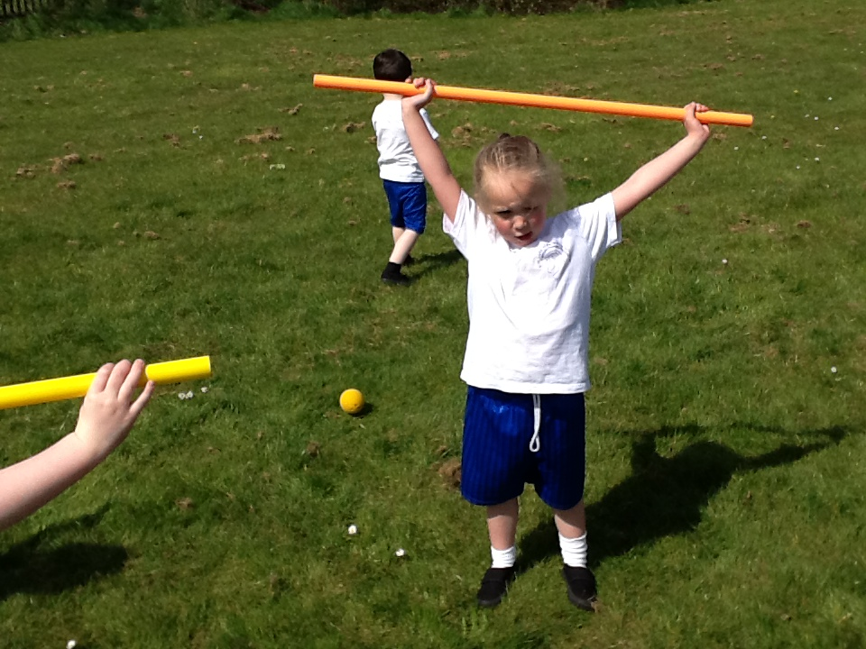

**No earrings for PE please**

Please put your child’s PE kit in a labelled PE bag

**Outdoor Clothing**

Children will be learning in the outdoor area, we would ask you to provide appropriate clothing for this.

Please bring in:

* **A large oversized t-shirt**
* **A pair of wellies**

These can then be kept in school.

**Please ensure ALL clothing is clearly**

**labelled with your child's name on.**



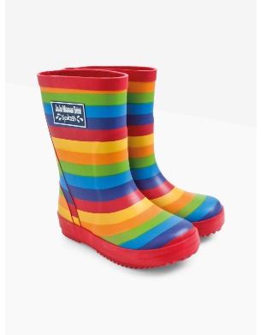

**Learning Journey**

* Whilst in Reception your child will have an individual Learning Journey.
* It will include photos of your child in various activities, examples of their work and written observations including their own written recordings/work.
* You are welcome to send in photos and comments from home to add to your child’s Learning Journey.

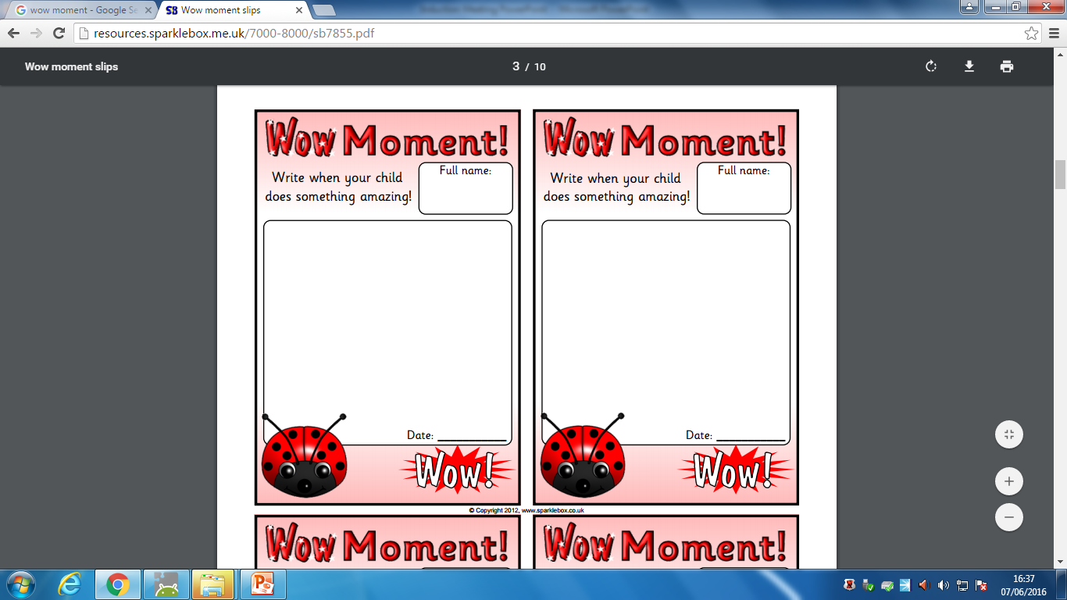

**Snack Money**

Snack money is paid via school COMMS online system, children do not need to bring in any money.

**Water Bottle**

Please ensure your child brings in

a full bottle of water into school every day.

**We ask you not to bring in any nuts in your child’s packed lunch as there are children with nut allergies.**

**Homework,**

**Library book and reading book**

* **Library book –** Sent home on Wednesday and brought back the following Wednesday.
* **Individual reading book –** Sent home on Monday and brought back on Friday.
* **Homework –** Homework will be communicated and sent out online. (Further details to follow)

**Communication between**

**home and school**

* Communication with staff
* School office
* Newsletters
* School website
* Reading record
* Wow moments
* Twitter

Key Dates

**Friday 7th September – Friday 17th September** – (2 weeks of morning and afternoon sessions). Children will come in for a morning session and stay for lunch (8.45am-12.00pm) or an afternoon session (1.00pm-3.00pm).

**Monday 20th September** – Children will begin school full time.

*Please drop your child off in Reception’s outdoor area through the wooden gate.*

*Please collect your child from Reception’s outdoor area exiting via the infant playground.*



If you have any questions or concerns please do not hesitate to contact us on 0151 424 6130 or email [Sec.OLPSprimary@halton.gov.uk](mailto:Sec.OLPSprimary@halton.gov.uk)

Admin.olpsprimary@halton.gov.uk

We hope your child will make lots of new memories and is looking forward to their school learning journey whilst at Our Lady’s.