**Lion Fact File**

Lions survive….

Lions live….

Lions eat….

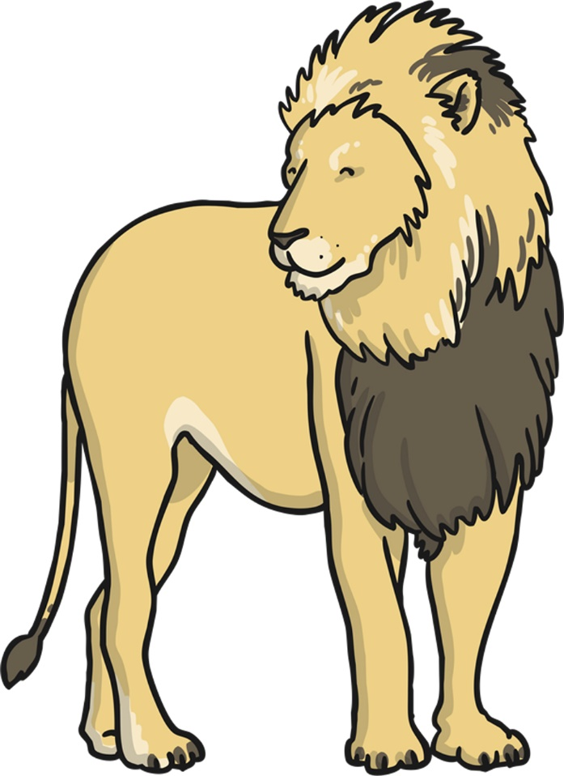

Elephant Fact –File

Elephants live….

Elephants survive….

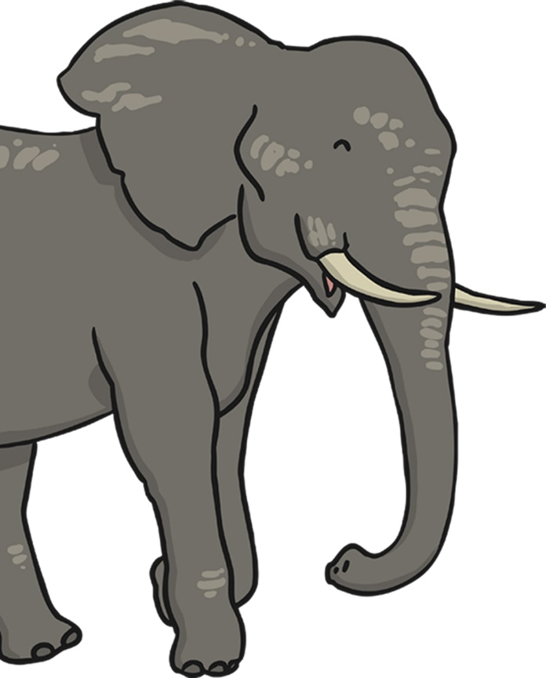

Elephants eat….