

OPAL NEWSLETTER
Summer update

Dear Parents/Carers.
Welcome to our Summer OPAL newsletter Lots of blue-sky and sunshine means our children have lots more fun over the past few weeks!

Benefits of OPAL PLAY:
The last few months of the school year and of OPAL play have been fantastic! As our evolving play provision has developed, it has inspired children to engage creatively with various resources and zones. With our new zones available for our children, this encourages them to become more active, to learn from mistakes, persevere through challenges, and develop resilience. When children associate play with positive experiences, it providesa more cheerful outlook which has had a successful impact on OPAL lunchtimes.

Stay and Play

On Tuesday 20th May, we invited families to our first Parents Stay and Play providing a morning and afternoon session.
Thank you to all the parents, carers, grandparents and other family members who attended It was lovely to see you engaging in the activities freely and I’m delighted to say it was a tremendous success!

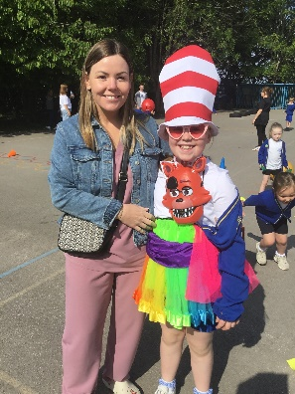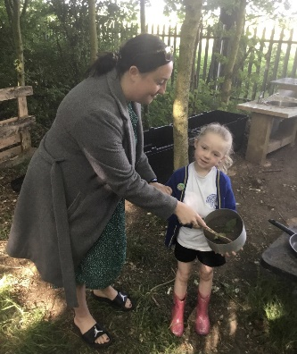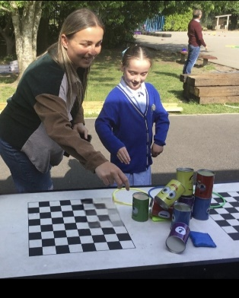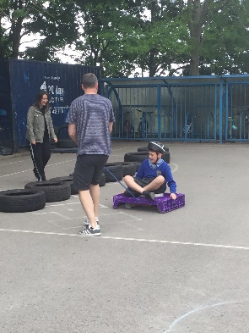

What we’ve introduced:
Sand Pit
After May half term we had a grand opening of our sand pit on Friday 13th June.
We had ‘A Dress for the Beach Day’ and we asked each child to dress in summer clothes and bring in an item to use and play in the sand pit with.
We had a great response and thankyou to all the parents who sent in items for the sand pit. The children had a fantastic time and have since enjoyed playing in the sand pit every day.
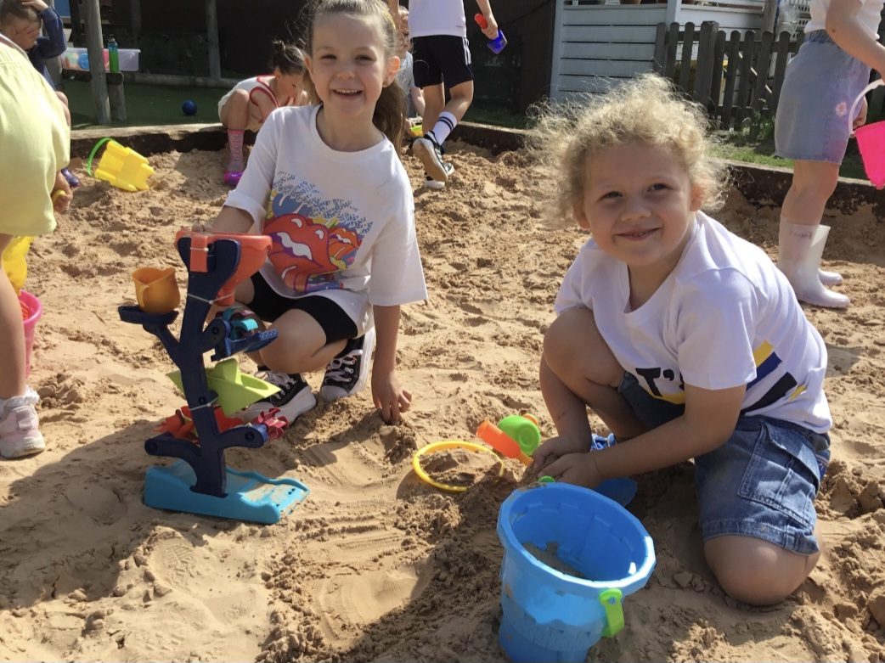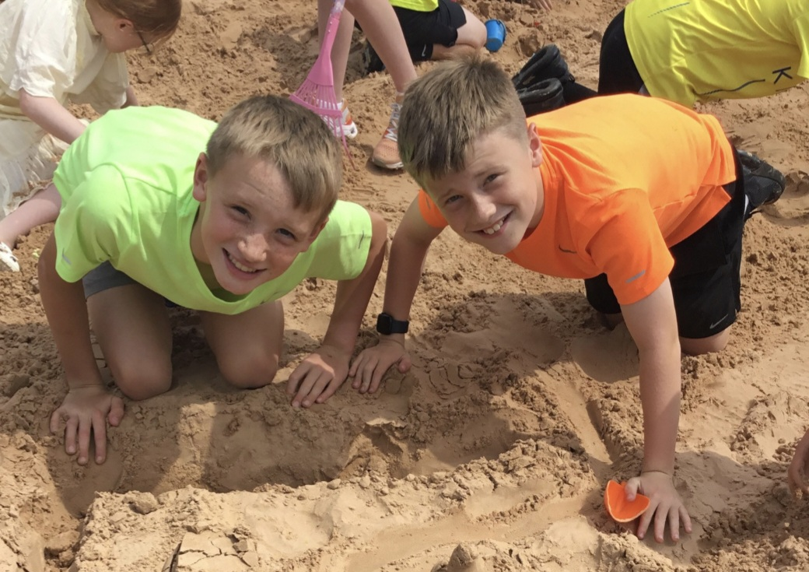

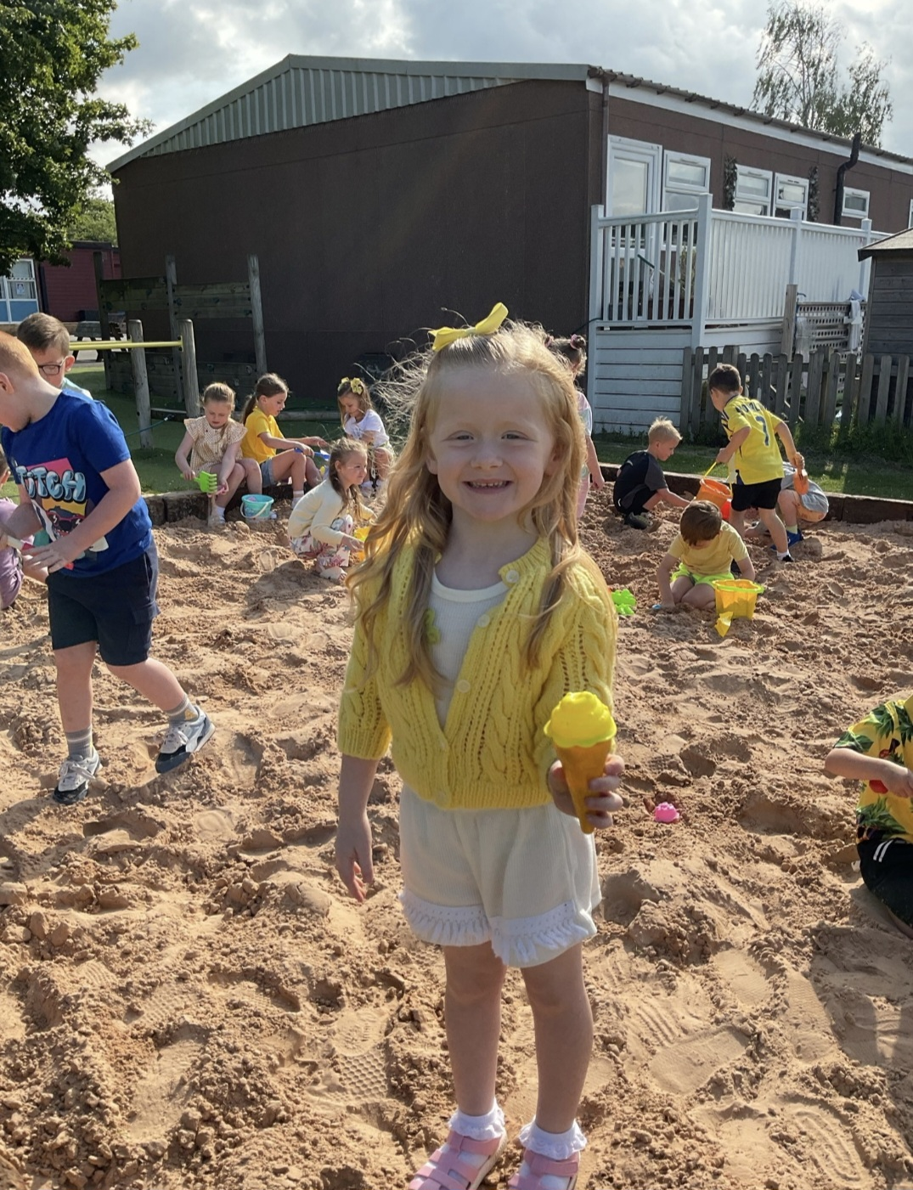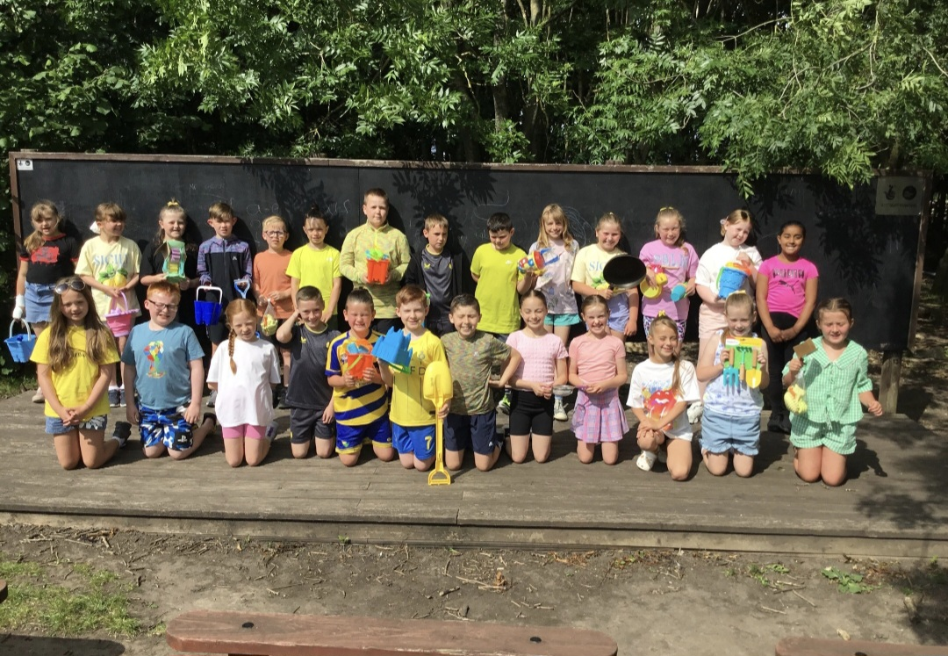

OPAL Certificates
We have introduced OPAL certificates which will be presented each Friday to a KS1 child and a Ks2 child. They will be picked by an OPAL team member for going above and beyond during lunchtimes. At the end of each half term those children chosen, will receive an OPAL extra playtime.
Golden Welly Award
This term we have introduced another OPAL award The Golden Welly Award which will be picked by our Year 6 Play Rangers for outstanding behaviour, good sportsmanship or showing initiative during play. Congratulations to our first winner.



What’s happening next:

Tesco Blue Token Scheme:
Thank you to everyone who went into the Widnes Tesco store and collected tokens and voted for our school. We are awaiting results from Tesco.
As Tesco says ‘Every little help’s and we will use the money to buy resources for OPAL.



Pallet Village
Mr Daniels is in the process of starting to construct a Pallet village’ a number of social spaces on our field area. The children will use these for quiet time, reading and chatting to friends. Once again, a huge Thankyou to Mr Daniels for all his hard work this year. Below is one he built for our sand pit resources.
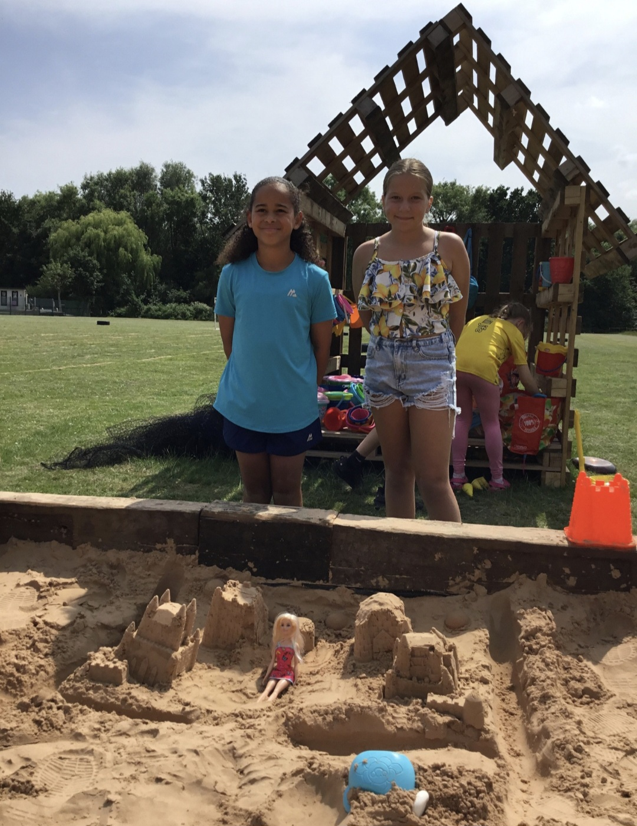

How can you help?
In September we would really appreciate any of the following:
- Toy cars, trucks
- Dinosaurs, action figures, farm animals
- Dolls, prams
- Roleplay toys such as play kitchen equipment, play mechanic/ builder, etc.
- Scooters or any other wheeled items (prams, trollies, etc)
- Blankets, shower curtains, fabrics for den building

As always, we are grateful for all donations.

Wellies
Also, as the summer is upon us by September the weather is interchangeable.
Thank you to all the parents who sent wellies in this year. We will be sending them home at the end of term and asking for your child(ren) to bring them back in September.
Our field area and woods can become very muddy when it rains so unless your child brings in a pair of wellies these areas will be restricted.
If your child outgrows their wellies we are always looking for donations. 

Thank you once again for your continued support making OPAL enjoyable and resourceful our children.



