

OPAL NEWSLETTER

OPAL update

Dear Parents/Carers.

Welcome to our first OPAL newsletter. We’re are currently implementing and developing the Opal programme at our school, which is aimed at enhancing various aspects of your children’s playtime experiences, increasing their physical activity, social interaction, imagination, individuality and enjoyment.

**Benefits of OPAL PLAY:**

During our first few months of OPAL play, it has been wonderful to observe the children having fun, being inspired and finding what makes them driven in their play. As a result of the independence that the children have to access different parts of the playground, with whoever they want, we have noticed that there is less time to be bored and playtime behavioural incidents have hugely reduced. Not only are the new play opportunities promoting health and well-being, but also children are developing life skills such as cooperation, team work and problem solving.

**What has happened already:**

**OPAL Play Team:**

Our Opal Play team is now in place and consists of **Mrs McGuffie, Mrs Heston** **Miss Poulson Miss Houghton** and **Mrs Reilly.** We meet every half term to put forward fun ideas and find creative solutions.

**OPAL Rangers:**

We now have a team of Year 6 rangers who help to make sure equipment is being used correctly, encouraging participation in play and at the end of playtimes help to collect and return equipment to the correct storage boxes.

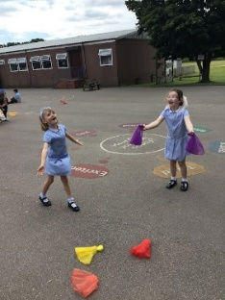

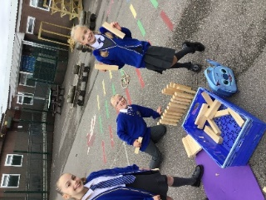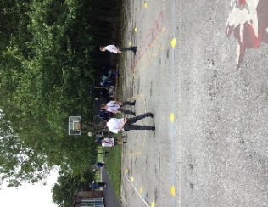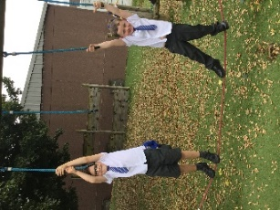

**Activities:**

Since the middle of July, our grounds have seen gradual introductions of new zones, activities and resources.

These include chalks, fancy dress costumes, bubbles, Giant Jenga and Connect 4, new boom box for the stage zone, a creative craft zone, space hoppers, wheelie zone (scooters) tyres and construction Lego K’nex, which the children are really enjoying!

**OPAL Web Page:**

We have a section on the school website (**under the OPAL tab**) dedicated to where you can keep up to date with the new developments, read more about OPAL and find out how you can help your child and the school in our OPAL journey.

Also look out for celebration of OPAL play photos on X follow us on **OLPS Widnes** @olpsprimary

**What’s happening next:**

Exciting things are being planned for the grounds such as a mud kitchen zone, a water zone and aden building zone.

**Mud kitchen**- We hope to build a mud kitchen in the next few weeks with the help from Mr Daniels. We have lots of resources to use donated in the OPAL Bingo.

**Water zone**- We will be planning and implementing a water zone see below for donations needed.

**Den building zone**- We’re in the process of planning a den building zone we will buying some resources and using items donated wooden pallets, cable reels and plastic crates.

**Wheelie Zone:**

Our wheelie zone is a great success and we are desperate to increase the number of wheeled items. We have purchased a few scooters but we are looking for more donations of old scooters. So, if your child has out grown or you have any unwanted scooters at home that our children would benefit from we would very much appreciate them.

**How you can help?**

As we are working towards making our playtimes more exciting no matter what the weather, we will need some equipment to help us do this.

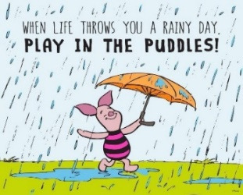

**Whatever the weather!**

To ensure all children have a safe and happy playtime, please ensure they come to school **every day** ready for whatever the weather.

***A polite reminder:***

For your child’s safety, now that the weather is unpredictable and changes daily**.** Providing wellies for access to different areas is advisable, as many areas are wet and muddy, **without wellies zones will be restricted!**

Ensure they have a **coat** in school and also **a spare pair of socks** may also be a good idea, in case of any leakages.

***We are saying no old trainers!***

Thank you to the parents who have provided wellies for their child(ren) already.

**Donations of the following would be greatly appreciated:**

**For the water zone:**

* Watering cans
* Paint brush
* Rollers
* Funnels
* Measuring jugs
* Small plastic cups

**For the den building zone:**

* Tarpaulin
* Tarp clamps, spring clamps, beach towel clamps
* Decking boards
* Tent pegs
* Cable drums/reels
* Plastic bale arm, milk crates

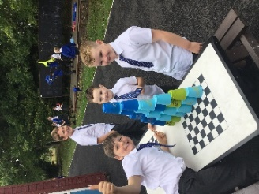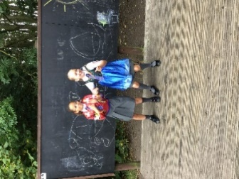

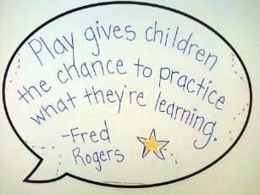

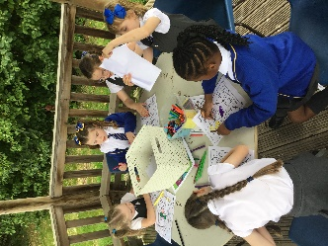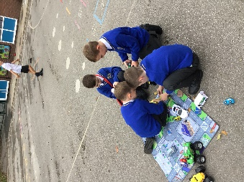

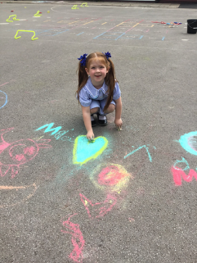

**Let’s keep working together to create incredible experiences for our children and continue to make play fun!**