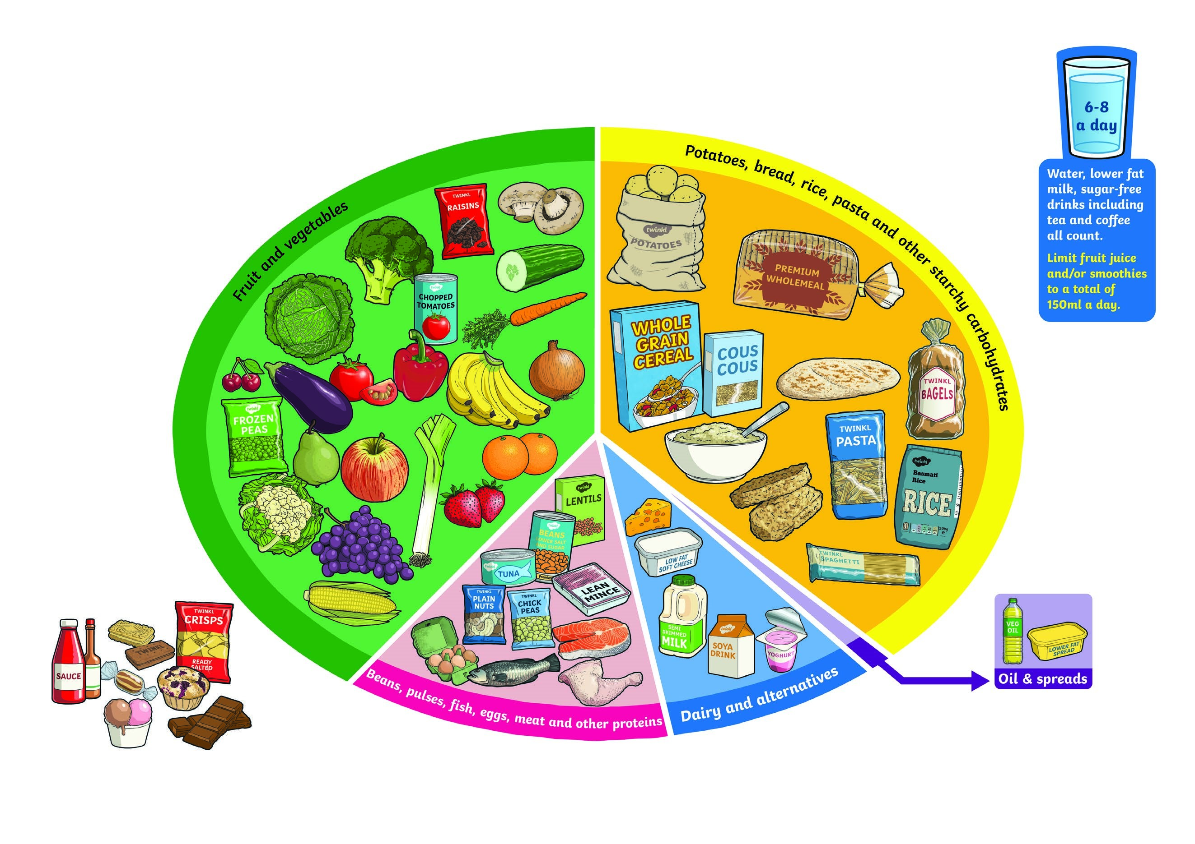

**Food Groups**

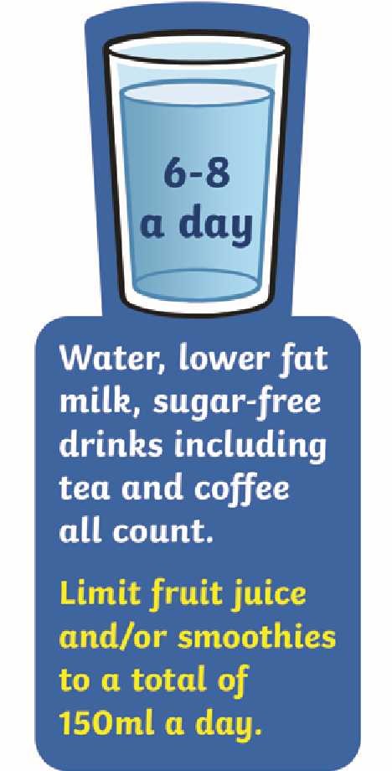

**Carbohydrates**

Starchy foods such as potatoes,

bread, rice, pasta and cereals should

make up just over a third of the

food you eat. These are important

for giving us energy. Choose higher-

fibre, wholegrain varieties, such as

wholewheat pasta and brown rice,

or simply leave skins on potatoes.

**Proteins**

Proteins such as beans, pulses, fish, eggs, meat are very

important for helping us grow and build muscles. Beans and

pulses are a good alternative to meat as they contain less fat

and are higher in fibre and protein. Try to eat 2 portions of fish

a week, and try to reduce intake of red and processed meat.

**Dairy and Alternatives**

These are a source of calcium which is

important for strong teeth and bones.

Choose lower fat and sugar options.

**Oil and Spreads**

Choose unsaturated oils and

spreads and use in small

amounts. Eat sparingly.

**Food and Drinks**

**High / or Sugar**

Eat less often and in

small amounts.

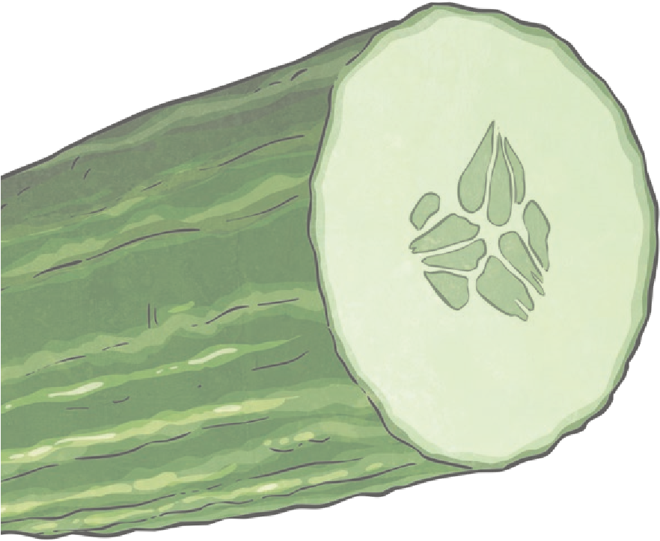

**Fruit and Vegetables**

These are good sources of vitamins

and minerals and fibre. Aim to eat

5

portions a day! Choose from fresh,

frozen, tinned, dried or juiced. Fruit

juice and/or smoothies should be

limited to no more than a combined

total of 150ml per day.

**visit twinkl.com**