Our Lady of Perpetual Succour Catholic Primary

Spelling Policy

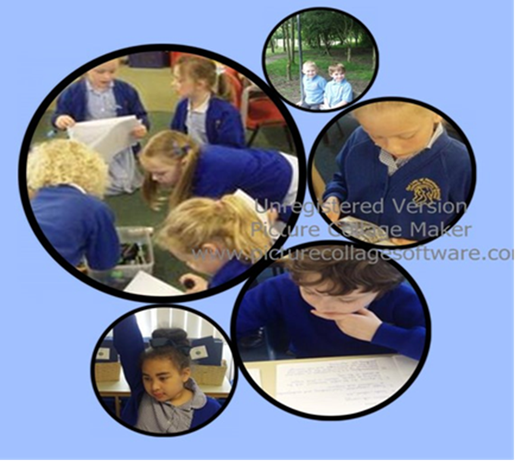

“We learn to love everyone as Jesus loves us”

Spelling and Phonics Policy

Here at Our Lady’s we believe it is vitally important that children are accurate and fluent spellers. Children are taught to do this at Our Lady’s by learning:

- The relationship between sounds and letters (phonics).
- Understanding morphology (word structure).
- Understanding orthography (spelling structure).

Aims:

- To establish consistent practice, progression and continuity in the teaching and learning of spelling and phonics throughout the school.
- To differentiate spelling and phonics work according to the needs of pupils, so that all pupils are given sufficient challenge at a level at which they can experience success.
- To give children word work strategies that will enable them to become fluent readers
and confident writers.

These aims will be delivered by:

- Word work taught explicitly, frequently and regularly.
- Careful differentiation for all ability groups, addressing the needs of children with special educational needs, including gifted children, based on ongoing formative assessment.
- Introduction of the ‘Word of the Week’.

Teaching Phonics

At Our Lady’s we equip our children for learning to read and write by developing their phonic knowledge and skills. We use the government produced scheme of work called ‘Letters and Sounds’, which sets out a detailed and systematic programme for teaching phonic skills for children starting by the age of five, with the aim of them becoming fluent readers by the age of seven.
Letters and Sounds is broken down into 6 phases which are worked through from reception to the end of year 2.Children have letters and sounds sessions which last approximately 20 minutes, and take place four times a week. At Our Lady’s we supplement the letters and sounds programme with Jolly Phonics materials and resources. High quality phonics sessions will be enhanced by a multi-sensory teaching approach, aware of different learning styles including visual, auditory and kinaesthetic.
All children who do not meet the required standard of reading at the end of Year 1 in the ‘Phonics Screening Test’, are identified for further support in small focus groups to benefit from extra practice. We are fully aware of the value of over-learning, i.e. revisiting and practising words. Little and often is the most effective method. During Year 2 those children will work in small intervention groups to catch up and consolidate.

Reception

Scheme of work | Letters and Sounds  Jolly Phonics
How often? | 5 times a week
Differentiation | LA pupils receive extra support in phases 1 and 2  HA pupils explore and deepen understanding up to phase 4 in the summer term
Structure / content | Letters and Sounds with Jolly Phonics  Daily 20 minute sessions
Where do we record spelling work? | English books and home/school diaries

Year 1

Scheme of work | Letters and Sounds
How often? | 4 times a week
Differentiation | KS1 are banded into ability groups:  LA consolidating phases 1-3  MA building up to phase 5  HA begin to work with Y2 pupils
Structure / content | Letters and Sounds  20 minute sessions
Where do we record spelling work? | English books – some work is completed orally or on individual whiteboards

Year 2

Scheme of work | Letters and Sounds  Read Write Inc – phased in alongside
How often? | 4 times a week
Differentiation | KS1 ability groups:  LA pupils who did not pass the phonics screening check to consolidate phases 1-5  MA/HA building up to phase 6 (complemented by ‘Read write Inc. Spelling’)
Structure / content | Letters and Sounds - 20 minute sessions  Introducing when appropriate:  Read Write Inc. - 15 minute sessions, daily
Where do we record spelling work? | English books / spelling journals – some work is completed orally or on individual whiteboards

Teaching Spelling

At Our Lady’s our spelling programme of study, draws upon a variety of resources and techniques: the main one being ‘Read Write Inc. Spelling’, which was developed by Ruth Miskin for children in years 2-6.
Spelling is taught discreetly as well as being embedded throughout the school day. Teachers also ensure that spelling rules are being reinforced when teaching any writing based activity. The programme of study supports the aims of the National Curriculum to ensure that children:

- Spell new words correctly and have plenty of practice in spelling them...including exception words and homophones.
- Spell words as accurately as possible using their phonic knowledge and other knowledge of spelling, such as morphology (the study of the form of words) and etymology (the study of the origins and development of words).
- Are supported in understanding and applying the concepts of word structure.
- Spell words that they have not yet been taught by using what they have learnt about how spelling works in English.

Year 3

Scheme of work | Read, Write Inc. Spelling
How often? | 5 times a week
Differentiation | LA to consolidate phase 6 Letters and Sounds  HA pupils explore and deepen understanding of Y3 spelling rules
Structure / content | Y3 ‘Read, Write Inc. spelling’  15 minute sessions
Where do we record spelling work? | Spelling journals – some work is completed orally or on individual whiteboards

Year 4

Scheme of work | Read, Write Inc. Spelling
How often? | 5 times a week
Differentiation | LA to consolidate Y3 content  HA pupils explore and deepen understanding of Y4 spelling rules
Structure / content | Y4 ‘Read, Write Inc. spelling’  15 minute sessions
Where do we record spelling  work? | Spelling journals – some work is completed orally or on individual whiteboards

Year 5

Scheme of work | Read, Write Inc. Spelling
How often? | 5 times a week
Differentiation | LA to consolidate Y4 content  HA pupils explore and deepen understanding of Y5 spelling rules
Structure / content | Y5 ‘Read, Write Inc. spelling’  15 minute sessions
Where do we record spelling work? | Spelling journals – some work is completed orally or on individual whiteboards

Year 6

Scheme of work | Read, Write Inc. Spelling
How often? | 5 times a week
Differentiation | LA to consolidate Y5 content  HA pupils explore and deepen understanding of Y6 spelling rules
Structure / content | Y6 ‘Read, Write Inc. spelling’  15 minute sessions
Where do we record spelling work? | Spelling journals – some work is completed orally or on individual whiteboards

Home / school links

In Reception, Key Stage 1 and Key Stage 2, spellings are regularly sent home: (in KS2 on a weekly basis). The children are asked to practice using the ‘Look, cover, write and check’ strategy. These spellings are based on the spelling rule being taught that week. In KS2 the children are then tested on these words at the end of the week.

Following the requirements of the new National Curriculum 2014, children in Key Stage 2 are also required to learn word lists in addition to their weekly spellings. We have split these into ten spellings for each half term to make the learning of these more manageable. See Appendix 1 for the full lists of these spellings.

Assessing spelling

At Our Lady’s we are mindful of the very individual needs of all our pupils, and all staff work hard to ensure that they are aware of individual children’s needs through all kinds of formative assessment.
In the Early Years Foundation Stage and Key Stage 1 spelling is assessed in class when children come to the end of each Letters and Sounds phase. In Year 1 and Year 2 children eligible for the Phonics Screening Check are tested regularly, throughout the year on real and nonsense words by carrying out a ‘practice’ phonics screening check. The data produced by the tests is then analysed so that vulnerable groups are identified and intervention is put in place.
Y2 pupils will also be given half termly tests, following the ‘Read Write Inc. scheme. This will prepare them for the end of key stage tests, and provide a bank of evidence for tracking progress.

In Key Stage 2 a weekly spelling test is administered to test the words that have been set for homework at the beginning of the week. In addition to this, a half termly diagnostic test also takes place where children are tested on words containing examples of the rules that have been studied during spelling sessions.

Marking Spelling

To highlight the importance of good spelling, it has been agreed that in any piece of written work completed by a child, a teacher should, where appropriate, mark or correct spellings accordingly.

Examples of when this correction may be appropriate include:

- A common, high frequency word, spelt incorrectly.
- A specific subject word, that has been given on the board, or in a word bank, and has not been recorded correctly.
- A word given in previous tests, which has been spelt incorrectly.

Information on how we mark incorrect spellings at Our Lady’s can be found in the Marking Policy.

Embedding Spelling

In view of the increased demands for greater accuracy and higher attainment boundaries in national tests, we will actively look for, and draw attention to, spelling patterns, examples and derivatives of spellings being studied in ALL AREAS OF THE CURRICULUM.
Whilst acknowledging that the lesson focus and success criteria may be scientific, geographical or religious, for example, we will utilize every opportunity to embed the morphology and etymology of words encountered on a daily basis.

Adopted by:

Headteacher / Staff

Governors

September 2017

To be reviewed September 2018

Appendix 1

