Our Lady of Perpetual Succour Catholic Primary School

Starting School Booklet

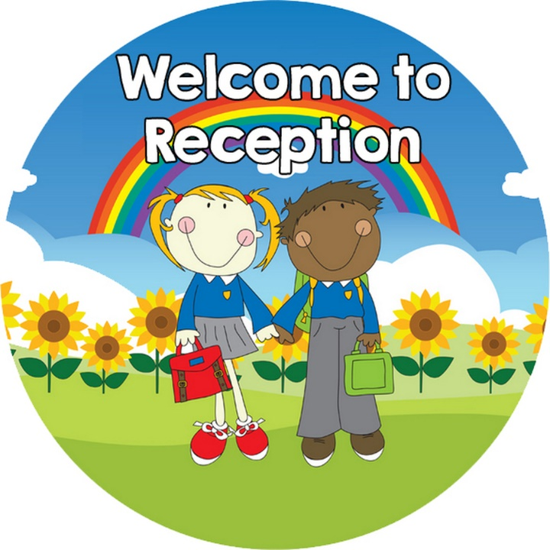

We learn to love everyone as Jesus loves us

Dear Parent/Carer,
Your child is about to start school. The first day is a momentous day in your child’s life - new friends, a new place, new sounds, more people; it is a whole new world. Every school day after that will be part of the developmental process of maturing, learning and growing. Starting school is an exciting time for young children and their parents. It can also be a daunting time too. But with a little preparation and encouragement most children will settle easily into school. I hope you find the information in this booklet helpful. I look forward to starting this journey with you and your child.
Miss Beger
(Reception Class Teacher)

On starting school children will flourish with ...
- A Positive Attitude
It is important to create a positive attitude towards learning. If children have this positive attitude then they will try to become involved in the learning process.

- Curiosity
The natural inquisitiveness of children can be encouraged. It is central to the learning process. Children will be encouraged to ask more questions when they get positive and encouraging responses.

- Self Confidence
If children are confident about their abilities and capabilities then they will be more willing to take on new challenges.

- Listening Skills
Children can be encouraged to develop good listening skills. Instruction and directions are given continually at school so children need to be good listeners if they are to participate fully in school life.

- Working Together
Children need to learn how to be sociable, how to share and take turns. They also need to learn respect for others and to be aware of the feelings of others.

- Independence
In order to take part fully in school life children need to have developed a good level of independence.

Preparing for School some Top Tips
Starting school is a milestone in the life of a child and can be a time of stress and anxiety for parents. Parents can do much to reduce such anxiety – both for themselves and their child. This preparation can begin some months before the child starts and can be carried out gradually.
It is an enormous change for a child to have to share a room with up to 29 other children. There is much that parents can do, however, to prepare children to cope with separation and socialisation and to help them get over their initial fears.
Some things to try
- An initial visit to the school is a good idea. Meeting the staff can help. Show your child the school building, and the playground.

- Talk to your child about your own school days. Emphasise the opportunities for making friends and for getting involved in new activities. Approach this talk with a calm attitude and treat it as a normal development in the child’s life.

- It is helpful if children can put on and take off coats and hang them up, use the toilet and flush it properly, wash their hands and tidy. Play ‘pretend school’ with your child.

- Help them to practice putting things in and out of their school bags.

- Teach them to share toys and take turns.

- Please label all your child’s clothes and belongings clearly and help them to identify their own belongings.

- Allow your children to do things independently, encourage confidence by having them dress themselves. Allow time for this in the morning.

- Praise their efforts at every opportunity.

Make things easy on yourselves
- Shoes with a velcro fastener will enable him/her to change quickly and independently.

- Ask yourself whether or not your child can manage his/her clothes by him/herself. Zips may be easier than buttons for example. Elasticated trousers can be easier than zips or buttons

The First Day at Our Lady’s
It is important that you establish a good routine early. Check that all items (school uniform, school bag, PE kit etc.) are ready for the morning. Do this in a calm fashion and don’t have your child over-excited or anxious going to bed. Give plenty of time in the morning for dressing, washing and eating a good breakfast.
On the big day, if you are feeling upset, don’t show it. Leave your child with the teacher, and tell him/her you will be back at the appropriate time to collect him/her. If your child is upset, trust the teacher. The teacher is very experienced and knows how to comfort an anxious child.
Above all talk to us, your child will be happy and successful at school if there is a strong partnership between us.

Some starting school books to read with your child.
- Starting School by Janet and Allan Ahlberg

- I am Too Absolutely Small for School by Lauren Child

- Maisy Goes to School by Lucy Cousins

- Going to School by Anne Civardi and Stephen Cartwright

