Come and See
The first topic this term is ‘Books’. Throughout this topic, the children will explore the different types of books that they use both at home and at school. They will learn about the importance of the Bible and read and retell some of the scriptures focusing on the Gospels. In the ‘Thanksgiving’ topic they will explore different ways we give thanks. Children will learn about ‘The Eucharist’ and the way the parish family thank God for Jesus. During both topics the children will have the opportunity for role play, discussions, art work and writing activities.

Vocabulary: Scripture, lectern, Gospel, Bible, New Testament, Old Testament,
thanksgiving, thoughtful, Eucharist, Eucharistic Prayer, liturgy

OLPS Values

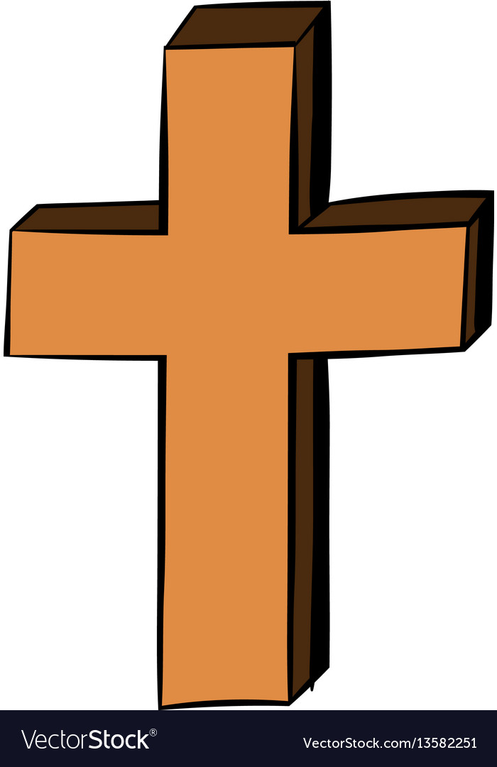
Main Texts

One day on our Blue Planet by Ella Bailey
By
Ella Bailey

Maths

In their maths work the children will consolidate their understanding of multiplication and division through problem solving and reasoning activities. They will be learning about fractions of amounts and will use their knowledge of division to help them. As well we will start to learn about 2-d shapes, looking at their properties and sort and classify these shapes. The children will learn the correct mathematical language to describe properties of these shapes. In arithmetic work we will focus on quicker recall of number bonds, 2x ,5x and 10x tables. The children will be introduced to using the TT Rockstars website at home to help them learn their times tables.
English

In English this term our focus text will be based on the book ‘One Day on Our
Blue Planet’ by Ella Bailey. This term the children will focus on writing non-chronological reports and descriptive settings. When writing the children will consolidate using a range of punctuation with increasing accuracy. Examples of the punctuation we will be focusing on are: full stops, question marks, exclamation marks and commas. Throughout this half term the children will develop their skills of self checking and correcting errors. In spellings they will learn a variety of word endings and revise all spelling rules taught this year so far. In guided reading sessions the children will read a ranch of fiction and non-fiction texts with increasing fluency and pace. They will use their reading across all curriculum areas and will be able to ask and answer questions about the text.
The children will continue to use the horizontal and diagonal strokes in their handwriting with all letters being correctly formed and clear neat presentation. In other curriculum areas they will have the opportunity to present their work to develop their speaking and listening skills.



Science
In this topic the children are looking at animals and their habitats. They will learn what do we mean by habitat. They look will look at different types of habitats, desert, polar regions, forests and school grounds. They will identify how animals are suited to their particular habitat such as weather conditions or type of land. They will classify and sort animals into different groups. Using websites such as World Wildlife Africa they will be to create information and non- chronological reports.
Vocabulary: Living, dead, never been alive, suitable, basic needs, food, food chain, shelter, move, feed, microhabitats.

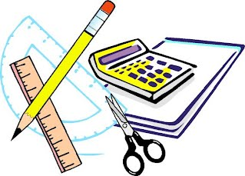

Geography

In our geography topic this half term, the children will study a locality outside of Europe - Africa. They
will use atlases and maps to locate oceans, continents and use compass directions. They will study the different types of land in Africa such as desert, rainforests and savannah. The children will look at how
the weather can affect the different types of landscape. They will learn basic facts about the continent
of Africa such as countries, seas and animals. We will use the story book ‘One day on our blue planet’
as a stimulus.

Vocabulary:

Africa, African Savannah, climate, continent, temperature, human, physical, tribes

Computing

In computing the children will use different digital devices to take photographs. They will edit their photographs and learn how to save them.
We will talk about the importance of asking for permission before taking a photograph.

STEM
Humanities

Art
We will be experimenting with paint in our art lessons this half term. We will be practising using different techniques and tools to help us paint and mix primary colours. We will create our own African animal pictures. We will show the process of exploring paint first in our sketch books and will sketch our drawings before we move onto creating the final picture.
Music
In our music lessons this half term, we will listen to and identify a range of instruments that are being played. We will copy and clap back rhythms and we will use percussion instruments while completing our charanga music lessons. We will be following the unit ‘Zoo Time’ in music.

Listen to and identify a range of instruments
Copy and clap back rhyth

Arts
PE

Tennis
Fitness

