All About
African Elephants

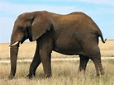

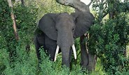

Contents:

The habitat of African
elephants Page 3

How are African elephants
suited to their habitat? Page 4

What do elephants eat
and drink? Page 6

Baby elephants Page 7

The Habitat of African Elephants

African elephants live in Sub-Saharan Africa. This is south of the Sahara Desert.

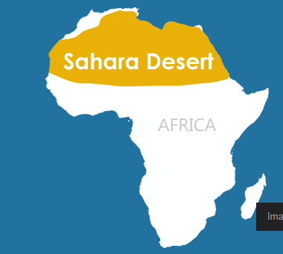

Elephants live here.

How are Elephants Suited to Their Habitat?

African elephants are the world’s largest land mammal. They have many interesting features including giant ears, long tusks, and a huge trunk

Why are Elephant Ears so Big?

Elephants flap their giant ears to cool off.

Fascinating Tusks

Elephants use their tusks to dig or scrape the bark off of trees. Sometimes they use them to fight. Their tusks can be up to 10 feet long.

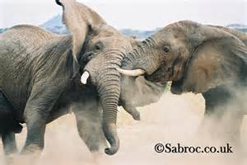
An elephant’s tusks Elephants fighting
Very Clever Trunks

An Elephant's trunk can be used for a lot of different things. They use them to:
pick up food as small as a blade of grass as well as to pull down tree branches to get to food. Trunks are also used to drink as well as well as to suck up water so they can spray themselves and have a bath. Sometimes these creatures throw sand and dirt on their backs to keep from getting sunburned.

Did you know that African elephants have two things which are like fingers on the end of their trunk? This helps them to pick up things.

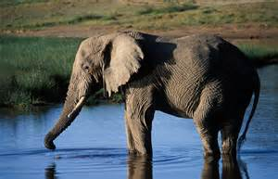
An elephant drinking

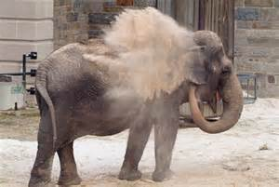

An elephant is spraying itself with sand to cool down.

Hearing and Smell
They have poor eyesight but excellent hearing and smell. They can hear each other's calls up to 5 miles away.

What do Elephants Eat and Drink?

Elephants are herbivores as they eat fruit, bark, plants, grass and roots. At least half of the food they eat is grass because it is easy to find. These animals eat a lot! They can eat up to 400 pounds of food each day. This is about the same as the weight of 3 people!
African elephants dig holes to find water underground. This also helps smaller animals find water when the ground is so dry. Elephants drink about 30 gallons of water each day. That is the same as about 136 bottles!

Elephants drink about 136 of these each day!
Baby Elephants

As elephants are mammals, they give birth to live young rather than eggs. A baby elephant is called a calf. Like all mammals, the babies feed off their mother's milk. Calves are hairy and usually about as tall as a Year 2 child.
These small calves drink their mother’s milk for a year and then they start to eat plants. By the time they are 2 or 3 years old, they stop drinking their mother’s milk completely.

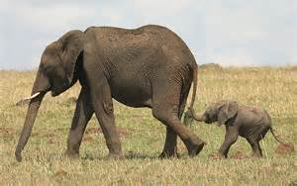

Fun fact!
Did you know that elephants live to be about 70 years old?

