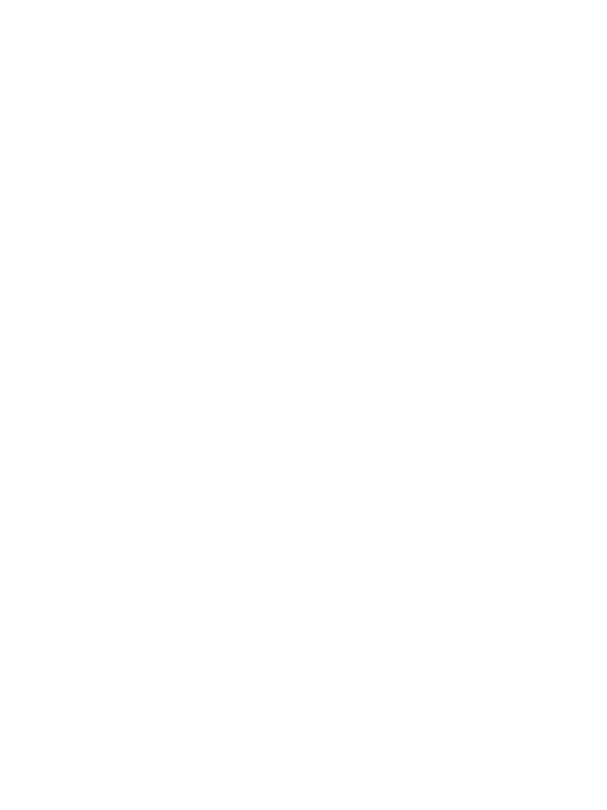

|  |  |
| --- | --- |
| **Features** | **Notes for my biography** |
| *Title* |  |
| *Overview* *paragraph* |  |
| *Childhood* *events* |  |
| *Early life,* *events and*  *achievements* |  |
| *Later life,* *events and*  *achievements* |  |
| *Concluding* *paragraph* |  |