**Our Lady of Perpetual Succour**

**Catholic Primary School**

**Design and Technology Policy**



**We learn to love everyone as Jesus loves us**

**Our Lady of Perpetual Succour Catholic Primary School**

**Curriculum Aims and Values**

**Intent**

At Our Lady’s we believe that Design and Technology will inspire children to think independently, innovatively and develop creative, procedural and technical understanding. Design and Technology provides them with opportunities to design, research, develop and represent their ideas, explore and investigate, make a product and evaluate their work. This will allow children to be exposed to a wide range of media including textiles and food; through this children will develop their skills, vocabulary and resilience. They will learn to become problem solvers who can work creatively on an independent or a shared project. Children are encouraged to be inventive, using a range of materials and tools, whilst developing, modifying and evaluating their ideas. As reflective learners they will evaluate their work, thinking about how they can make changes and keep improving. Children are encouraged to take risks and experiment and then reflect on why some ideas and techniques are successful or not for a particular project.

**National Curriculum – Design and Technology**

Purpose of study

Design and Technology is an inspiring, rigorous and practical subject. Using creativity and imagination, pupils design and make products that solve real and relevant problems within a variety of contexts, considering their own and others’ needs, wants and values. They acquire a broad range of subject knowledge and draw on disciplines such as mathematics, science, engineering, computing and Art. Pupils learn how to take risks, becoming resourceful, innovative, enterprising and capable citizens. Through the evaluation of past and present design and technology, they develop a critical understanding of its impact on daily life and the wider world. High-quality Design and Technology education makes an essential contribution to the creativity, culture, wealth and well-being of the nation.

**Aims**

The national curriculum for Design and Technology aims to ensure that all pupils:

* Develop the creative, technical and practical expertise needed to perform everyday tasks confidently and to participate successfully in an increasingly technological world
* Build and apply a repertoire of knowledge, understanding and skills in order to design and make high-quality prototypes and products for a wide range of users
* Critique, evaluate and test their ideas and products and the work of others
* Understand and apply the principles of nutrition and learn how to cook.

**Our Ladys Primary School Curriculum**

We teach a bespoke personalised broad and balanced curriculum. This curriculum is highly relevant to our pupils' needs here at Our Lady’s and thoroughly engages them as they tackle challenging and inspiring topics.

**Why is Design and Technology important?**

Design and Technology helps us to develop as reflective learners, as we work through the design process. Through Design and Technology we are able to work collaboratively to solve problems and find solutions, teaching us to deal with uncertainty whilst developing communication, organisational and other practical life skills. In Design and Technology, we learn to appreciate the needs of others, the built environment and the likely impact of future technologies.

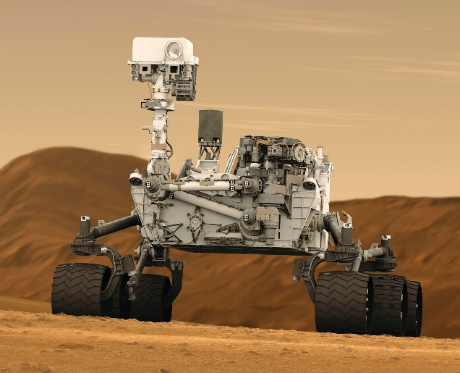

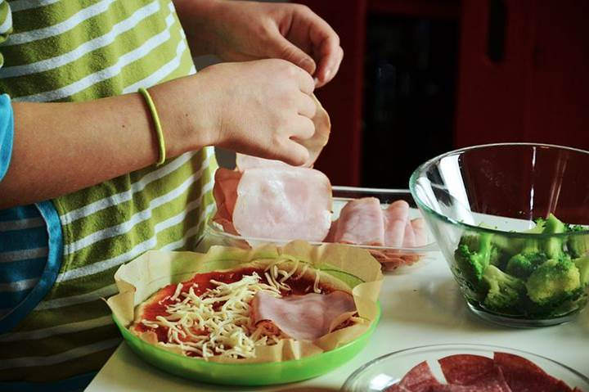

**Pupils develop their communication skills through design technology, when they are sharing ideas and explaining their thinking.**

**Design Technology teaches pupils to understand and apply the principles of nutrition and learn how to cook.**

**Design Technology gives pupils the opportunity to develop skills, knowledge and understanding of designing and making functional products.**

**Implementation**

**When is Design and Technology taught?**

Design and Technology is taught using ‘Projects On A Page’ (POAP). Design and Technology is taught each week and allows for the development and progression of knowledge, skills, vocabulary and understanding within Design and Technology.

**How is Design and Technology taught?**

Design and Technology is taught through a combination of subject knowledge, skill building and design and make projects using the POAP planning (Projects On A Page). Design and Technology engages pupils in a range of designing and making activities which involve a variety of different methods, e.g. speaking, designing, drawing, assembling, making, writing and using ICT. All pupils design, make and evaluate and are challenged within this process. The teaching of D&T is planned to ensure progression of skills, knowledge and understanding throughout each Key Stage. Learning takes place both inside and outside the classroom. Cooking and Nutrition is taught across the school using a cross-curricular learning approach and is incorporated into individual lessons related to the topic as well as during ‘Healthy living’ week.

In the Early Years, Expressive Arts and Design is one of the four key areas of the EYFS framework. Pupils will explore and play with a wide range of media and materials, as well as have opportunities to share their thoughts, ideas, and feelings through a variety of activities in art, music, movement, dance, role-play, and design and technology.

**What do we learn in Design and Technology?**

Through a variety of creative and practical activities, pupils are taught the knowledge, understanding and skills needed to engage in the process of designing, making, evaluating and gaining Technical Knowledge.We complete Design and Technology projects in exciting contexts that reflect real life situations. For example, designing and making free standing structures, designing and making a vehicle that moves, designing and making a toy that moves, as well as celebrating culture and seasonality.

**SMSC**

**Design Technology helps children to problem-solve, making on-going changes and improvements during the design and make process.**

Collaborative work in D&T develops mutual respect for the differing opinions, beliefs and abilities of others. In addition, children develop a respect for the environment, for their own health and safety and that of others. They learn to appreciate the value of similarities and differences and learn to show tolerance. A variety of experiences teaches them to appreciate that all people and their views are equally important.

**Impact**

Assessment and feedback to pupils is usually carried out by observation and oral feedback during lessons. Children are encouraged to reflect on their D&T work as it progresses, and evaluate their finished piece. Subject leaders are continuously monitoring their subject to ensure that it meets the needs of our pupils. Senior Leaders also monitor each curriculum subject. This is done through:

* Learning walks
* Book scrutiny
* Lesson observations
* Pupil surveys and discussions/Pupil Voice
* Staff surveys and discussions.

The class teacher is responsible for assessing all areas of Design and Technology and logging the progress of each child using O-Track to assess against each of the objectives taught.

**Role of the co-ordinator**

* Develop Design and Technology within the school.
* Monitor the standards of teaching and achievement of skills.
* Establish high expectations for all pupils and ensure their consistent achievement.
* Provide support to staff.
* Audit resources on an annual basis and replenish as necessary.
* Attend courses and pass on any new subject developments to teaching staff.

**Resources**

There are a wide range of resources available for staff to use to teach D&T. D&T equipment/resources are stored in the Art cupboard and resource room. New resources are purchased at the end of the academic year (July). Any extra resources are ordered and purchased throughout the year when needed.

**Design and Technology co-ordinator:** Jenny de-Beger

**Policy Updated:** September 2023

**Policy Review Date:** September 2025

**Appendix 1**

**Design and Technology Topic Overview**

|  |  |  |  |  |  |  |
| --- | --- | --- | --- | --- | --- | --- |
| **2023-2024** | **Autumn 1** | **Autumn 2** | **Spring 1** | **Spring 2** | **Summer 1** | **Summer 2** |
| **Reception** | So Much  The Leaf Thief | The Jolly Postman  Stickman  The Nativity | Whatever Next | LRRH  The Three Little Pigs  Design and make a house for the pigs | The Caterpillar  What the Ladybird Heard  Design and make a healthy smoothie | The Naughty Bus  Rainbow Fish  Design and make a Naughty bus |
| **Year 1** | Unity in the Community | The Beatles  Design, make and evaluate a finger puppet of the Beatles  POAP – Templates and joining | Building Bridges  Design, make and evaluate a vehicle that moves. (Transport mechanisms)  POAP – Wheels and axels | Rainforest | The Arctic | Royal Patrons (The Queen)  Design, make and evaluate a fruit salad for the Queen  POAP – Preparing fruit and vegetables |
| **Year 2** | NESW | Remember Remember  Design, make and evaluate a slider/ lever on a card. (Mechanisms)  POAP – Sliders and Levers | Africa | Africa | I do Like To Be Beside the Seaside  Design, make and evaluate a healthy sandwich  POAP – Preparing fruit and vegetables | The Great Fire of London  Design, make and evaluate a house using different materials.  POAP – Freestanding structures |
| **Year 3** | Journey to Greece  Design, make and evaluate a Greek meal  POAP – Healthy and Varied diet | Three Giant Steps (Dover, France and Canada) | The Stone Age  Design, make and evaluate a flag.  POAP – Levers and linkages | Victorians | Victorians  Design, make and evaluate a Victorian trinket.  POAP – 2D shape and 3D product | Rainforests of SE Asia |
| **Year 4** | Lightning Speed  Design, make and evaluate a simple switch circuit with a switch  POAP – Simple circuit and switches | Visit the Mediterranean  Design, make and evaluate a healthy meal  POAP – Healthy and Varied diet | The Romans | The Romans  Design, make and evaluate an amphitheatre  POAP – Shell structures | The Saxon King | Brazil vs Scotland |
| **Year 5** | Mission Control Earth and Beyond | WW2  Design, make and evaluate an apron  POAP – Combining different fabric shapes | In Your Element  Earth, Air, Fire, Water  Design, make a mechanical system using pulleys and gears  POAP – Pulleys and gears | Design, make and evaluate a healthy meal  POAP – Celebrating culture and seasonality | The Egyptians | North America |
| **Year 6** | Bright Ideas  Design, make and evaluate an electrical product  POAP-Monitoring and control | Survivor  Design, make and evaluate a shelter  POAP – Frame structures | South/Central America | South/Central America | The Vikings | Global Warning  Design, make and evaluate a fair trade healthy meal  POAP – Celebrating culture and seasonality |