Our Lady of Perpetual Succour
Catholic Primary School



Religious Education
Handbook

"We learn to love everyone as Jesus loves us."

Contents
Page

Contents Page 2

Mission Statement 3
Aims of Religious Education 4
Objectives of Curriculum RE 4
Expectations of Classroom RE 4
Religious Education Programme 5
Overview of Content 5
Process 7
Planning 11
Differentiation 12
Assessment 12
Attainment Targets and Levels of Attainment 14
Recording 15
Reporting 15
Evaluation of Teaching 15
Evaluation of Learning 16
Staff Development 16
Staff Induction 16
Staff Communication 16
Relationship of RE to the Whole Curriculum 17
Links with parents 17
Links with our parish 18
Inter-relationships with other school policies 18
Special educational needs 18
ICT 19
Display 19
Cross phase links 19
Equal opportunities 20
Review 20
Annual Planner 21
Resources – Teaching 22

MISSION STATEMENT

"We learn to love everyone as Jesus loves us."

In fulfilling our Mission Statement we aim to:

- Be a gospel-centred community;
- Provide a loving, welcoming environment where the Christian faith is nurtured;
- Develop potential and celebrate the achievements of all.

Therefore with the children we will:

- Teach them to love and respect self and others, by following in Jesus’ footsteps;
- Enable them to feel happy, safe and valued;
- Help them to work to the best of their ability.

With staff we will:

- Enable them to grow in both personal and professional self-respect and self-confidence;
- Serve the Church through love and service of the children;
- Work together, encouraging one another and sharing good practice.

Our curriculum will

- Teach the values of the Gospel;
- Be broad and balanced, interesting and stimulating;
- Have a spiritual and moral dimension interwoven within it;
- Provide opportunities for all to succeed
- Enable all to go into the modern world with skills and competences that will allow them to be accomplished and to thrive as followers of Jesus.

The Aims of Religious Education

Our aims are taken from Religious Education Curriculum Directory (3-19)
for Catholic Schools and Colleges in England and Wales, 2012

We aim:

- To present engagingly a comprehensive content which is the basis of knowledge and understanding the Catholic faith;
- To enable pupils continually to deepen their religious and theological understanding and be able to communicate this effectively;
- To present an authentic vision of the Church’s moral and social teaching so that pupils can
make a critique of the underlying trends in contemporary culture and society;
- To raise pupils’ awareness of the faith and traditions of other religious communities in order to respect and understand them;
- To develop the critical faculties of pupils so that they can relate their Catholic faith to daily life;
- To stimulate pupils’ imagination and provoke a desire for personal meaning as revealed in the truth of the Catholic faith;
- To enable pupils to relate the knowledge gained through Religious Education to their understanding of other subjects in the curriculum;
- To bring clarity to the relationship between faith and life, and between faith and culture.

The Objectives of Curriculum RE

In January 2000, a National Symposium on ‘Expectations of Religious Education in Catholic Schools’ was hosted by the Bishops’ Conference of England and Wales. The Bishops’ issued a statement highlighting the following points.

The objective of religious education requires:

• analysis and reflection and critical appreciation of sources,
• marked progression through the different stages of education,
• the unequivocal support of the management of every Catholic school,
• 10% of the length of the taught week for each Key Stage of education,
• the encouragement of investigation and reflection,
• development of appropriate skills and attitudes which allows for a free, informed response to
God’s call in everyday life,
• the use of skills in other areas of the curriculum.

Expectations of Classroom Religious Education

Classroom religious education in a Catholic school is primarily educational and we strive to achieve excellence in religious education by:

– clarity of succinct religious learning objectives,
– key content,
– by appropriate methodologies,
– rigour,
– richness of resources,
- achievement of identified outcomes,
– accurate methods of assessment.

The Religious Education Programme

To fulfil our aims and objectives we use the ‘Come and See’ programme of Religious Education recommended by the Archdiocese of Liverpool.

Overview of content

Come and See is developed through three themes based on the above documents of the Second Vatican Council, which are gradually explored each time at greater depths. They are Church, Sacrament and Christian living.

The basic question belief for each season time is explored through three kinds of themes:

Community of faith: Church
Celebration in ritual: Sacraments
Way of life: Christian Living

Church

The Church themes occur in each season time and each theme gradually builds on the understanding of the previous theme.

Autumn – My story ~ my family ~ Domestic Church. To start the year Come and See begins with my story: within a family. The Church honours the family with the title Domestic Church because it is there that parents ‘by their word and example are the first (teachers) heralds of faith with regard to their children.’

Spring – Our story ~ local Community ~ Local Church. After Christmas the children explore the theme of local Church which is our story. The parish is where people gather together to celebrate and practice care and love for each other. The diocese is the community of the Christian faithful.

Summer – The story ~ the worldwide community ~ Universal Church. The year finishes with the story of the worldwide community; the universal Church. In the Church, God is calling together his people throughout the world.’16 ‘The order and harmony of the created world result from the diversity of beings and from the relationships that exist among them’17

Sacrament

The Sacramental themes occur once in every season time and each theme gradually builds on the understanding of the previous theme.
Autumn – Belonging ~ born into Christ’s life. Following on from an understanding of belonging to a family the theme of Baptism introduces the understanding of being initiated into belonging to the Christian Church during key stage 1. ‘The faithful are born anew by Baptism, strengthen by the sacrament of Confirmation, and receive in the Eucharist the food of eternal life.’
At key stage 2 children will learn about the Sacrament of Confirmation, whereby the baptised are more perfectly bound to the church and are enriched with a special strength of the Holy Spirit, the Sacrament of Ordination for the service of the Church and the Sacrament of Marriage, perfecting the human love of wife and husband.

Spring – Relating ~ God’s love in our lives ~ Eucharist. In the Spring time after learning about the local Church community, the Sacrament of the Eucharist is explored. This is the Sacrament of communion with Christ and the Church. This sacrament is at the heart of Come and See since it is at the heart of Christ nourishing his people.

Summer – inter-relating ~ service to the community ~ Reconciliation. The Sacrament of Reconciliation forms part of the work of the summer time when there an opportunity to learn about the joy and challenge of relationships and God’s love and mercy celebrated in this sacrament. At key stage 2 children will learn about the Sacrament of the Anointing of the Sick, which strengthens, forgives and unites the ailing person more closely to Christ.
Theological foundations

Christian living

The Christian living themes occur in each season time and each theme gradually builds on the understanding of the previous theme.
Autumn – celebrating life – Advent Christmas. The Advent – Christmas theme considers the gift of God’s love in Jesus. Christmas and our preparation celebrate the wonderful gift of Jesus and offers the witness of loving as a way of life. ‘The Word became flesh so that we might know God’s love.

Spring – giving – the cost of life –. In the Spring season Lent and Easter are explored, Jesus’ love for humankind knows no limit. Jesus offered his life and gave an example of giving as a way of life. ‘Easter is not simply one feast among others, but the feast of feasts.’
‘The Resurrection … remains at the very heart of the mystery of faith as something which transcends and surpasses history.’

Summer – serving in love – feasts to celebrate – Pentecost. The study of the Ascension and Pentecost completes the Easter story and shows how the gift of the Holy Spirit strengthens the community and enables Christians to give witness to a life of joyful service. ‘In this age of the Church, Christ now lives and acts in and with his Church, in a new way appropriate to this new age.’

Each theme is explored through different topic in each age group:

The themes of each season

AUTUMN

The three autumn time themes are developed in the light of an understanding of Creation:

• Family Domestic Church focuses on life as gift, myself as a unique and loved creation,
the creative love and care that can be expressed in family groups.
• Belonging Baptism/Confirmation focuses on the call to belong, the creative potential that belonging develops; and Baptism and Confirmation, sacraments of the gift of God’s life and friendship.
• Loving Advent/Christmas focuses on the capacity for entering into loving relationships
and the perfect gift and revelation of God’s love, Jesus, born of Mary, born as one of us.

SPRING

The three spring time themes are developed in the light of an understanding of Incarnation:
• Community Local Church focuses on the people of God gathered in Christ, united in the
journey of faith, in care for one another, in sharing their story and in celebration.
• Relating Eucharist focuses on the invitation to know Jesus, to live in communion with
him and with one another.
• Giving Lent/Easter focuses on Jesus’ loving self-giving on the cross, the Father’s love
that raises him to new life and the challenge to Christians to follow Jesus’ example of self-giving.

SUMMER

The three summer themes are developed in the light of an understanding of Redemption and the work of the Holy Spirit.
• Serving Pentecost focuses on the on-going mission of Jesus Christ in the Church
through the power of the Holy Spirit.
• Inter-Relating Reconciliation focuses on the love, compassion and forgiveness of God the Father revealed in Jesus and poured out by the Spirit to bring forgiveness and reconciliation in the sacrament of Reconciliation.
• World Universal Church focuses on the same love revealed in the diversity of the world
and its people, and in the gifts of the Spirit that bear fruit in love, joy, justice and peace for all people.

The process

It is necessary, therefore, that Religious Education in schools be regarded as an academic discipline with the same systematic demands and the same rigour as other disciplines. It must present the Christian message and the Christian event with the same seriousness and the same depth with which other disciplines present their knowledge. However it should not simply be regarded as one subject among many, but rather it should engage in interdisciplinary dialogue.
……Religious Education in schools underpins, activates, develops and completes the educational and catechetical activity of the whole school.

Religious Education Curriculum Directory 2012
The Catechism of the Catholic Church addresses the human search for meaning, God’s initiative in Revelation who comes to meet us and our response of faith. This pattern guides the structure of the programme and informs the process of each topic, opened up through; Explore, Reveal and Respect.

The Process:

The Word who is life – this is our subject

Search- Explore

This is the introduction to the topic where the children’s life experience is explored, the question(s) it raises are wondered at, shared, investigated and their significance reflected upon.

Revelation- Reveal:

This is the heart of the programme where knowledge and understanding of the Catholic faith is revealed through the Word, in Scripture, Tradition, doctrine, prayers, rites and Christian living.

Response- Respond

This is where the learning is assimilated, celebrated and responded to in daily life.

EXPLORE

The teacher helps the children to begin to look at and focus on the experience within their own lives – concerning themselves, their relationships and their world. In this way the children are led to a deeper understanding, clearer vision and the discovery of significance and value of the experiential events of everyday life.
This will involve:
• Exploring experiences through story, music, drama, dance, art, etc
• Investigation
• Story telling
• Consideration of the big questions
• Discussion
• Becoming aware of the questions raised
• Reflecting on significance of these experiences.

Religious Education learns from evangelisation and catechesis that learning and growth involve active participation and response. For this reason, personal experience plays a significant part in the exploration, discovery and assimilation of the saving truth of God’s revelation.

Religious Education Curriculum Directory 2012

Explore will take one week of Religious Education time to complete.

REVEAL

Reveal is the heart of the process. The teacher and the children together discover the Christian understanding of the mystery of the Trinity; Father, Son and Holy Spirit. They explore the mystery of human life as revealed in the person, life and gospel of Jesus Christ Christians. It will involve learning about Scripture, the teaching of the Church, prayers, rites, psalms, hymns and other expressions of Christian faith and the lives of outstanding Christians.
The process of delivery will involve:
• meeting new knowledge of religious education;
• developing an understanding of this new knowledge;
• reflecting on the wonder of the mystery;
• gathering information and collecting facts connected with this knowledge;
• researching, collating and classifying;
• becoming aware of the questions raised;
• working with problems and grappling with puzzling experiences;
• exploring experiences through story, music, drama, dance, art;
• exploring what leads to understanding and meaning;
• asking questions and discussing;
• exploring in creative and practical ways through drama, writing, poetry, song, dance, music,
ICT and service of others;
• making links between Christian understanding and the shared life experience;
• valuing life experience;
• acknowledging and respecting difference(s);
• being open to new perspectives.

REVEAL will take two weeks of Religious Education time to complete.
Theological foundations

RESPOND

Remember is the first part of this section. The children will respond by remembering and celebrating all that they have learnt. This new understanding will enable them to make a personal response in their daily lives. This part begins by reflecting on what the children wonder about. This is followed by providing the opportunity for the children to remember what they have understood and learnt.
This may be done through:
• creating a quiet, prayerful atmosphere for reflection
• looking at and thinking about the work done
• drawing attention to different aspects of this work
• sharing thoughts and feelings.

Rejoice is the second part of the section. There is the opportunity to plan and take part in a celebration. It will be essential to involve the children in the choice of material to be used in the celebration.

G
So we will:

Consider how the children will begin the celebration.

WORD – LISTEN

To some scripture read or enacted

RESPONSE

How will the children respond to all they have heard?

GOING FORTH

How will the children take away the message?

Renew the teacher helps each child to make an individual response, to hold on to and make their own, what they have understood of the topic. In this part the children will think about how they can apply their learning to their lives.
Older children can be offered the opportunity to write or draw in their personal notebooks.
The teacher will undertake an evaluation which will inform future teaching and learning and include assessment for learning.

RESPOND will take one week of Religious Education time to complete.

Planning

Time allocation curriculum
The Bishops requirement of 10 percent of the curriculum teaching time is clearly indicated on class timetables. This time does not include time for collective worship and hymn practice. Teachers arrange their own timetable, which is checked by the senior management team.

Long-term planning

The themes and topics framework sets out the programme for the year.

Within all classes, teachers have regard for the attainment levels when developing activities for children of different age groups and abilities. We track individual pupils’ experience of the topics to ensure full coverage and to avoid duplication. The school leadership monitors this.

Medium-term planning

Medium-term planning is the responsibility of the R.E co-ordinator
The RE Co-ordinator:-
- Uses the overview in Come and See to note the basic question and Christian doctrine for the term;
- Uses the theme pages to note
∗ the content and the focus of each theme;
∗ links to the catechism of the Catholic Church and Religious Education Curriculum Directory 2012;
∗ key concepts, skills and attitude;
∗ attainment targets.

- Provides a planner for each term’s work – this is supplied by the archdiocese and photocopied by the co-ordinator and given to staff. It includes:
∗The basic question ↔ Christian doctrine for the term;
∗The three themes and topics through which these will be explored;
∗Starting dates for each topic;
*Feast days and holy days;
*Special notes for planning;
*Global dimension;
*Other faith weeks.

Short-term planning

This is the responsibility of the class teacher. The teacher uses the planning model provided by the school. The amount of detail required will vary from topic to topic and class to class. The class teacher will:-
- Plan the topic to ensure achievement of the three learning outcomes;
- Select appropriate activities for the whole class or groups of children;
- Indicate the children to be assessed, either, the whole class, groups or individuals and the activities chosen for this. Select 3 children for moderation during each topic.

Differentiation

As with all other areas of the curriculum the purpose of differentiation in religious education is:
• To enable children to succeed in the set task or activity and to challenge them to take the next step in learning;
• To challenge children to be self-motivated and to take responsibility for their own learning;
• To enable children to recognise and celebrate their achievement;

Children learn in different ways, so as with other subjects, we provide a range of learning activities using a variety of media.

Assessment

Assessment in religious education is related to the concepts, skills and attitudes to be developed through learning about and learning from religion.

Assessment establishes what children know, understand, can do and how to get there. It offers support and motivation to the learner. It
does not assess spirituality or the practice of faith.

At the beginning of Explore and Reveal there is an indication of the Areas of Learning and the
Attainment Levels which are covered. At the end there is a summary of the levels for that topic.

Regular assessment, individual pupil tracking and record keeping are carried out according to the direction given by the diocese, in order to ensure pupil progress.
At Our Lady’s this involves:

Informal Assessment

- Marking
- Discussions
- Observations
- Plenary

Formal Assessment

- Each child is assessed once a term by the class teacher (as advised by the Archdiocese)
The Archdiocese informs our school which topic and which section of the topic to assess to gain a wide range of assessments throughout the children’s school life. Children evaluate their work at the end of every topic.
- RE books, planning and lessons are monitored by the Head Teacher and the co-ordinator
- Learning is continuously assessed through each topic and children above and below expectations are noted on all short term plans.

Expectations

In each topic, teachers are offered brief summaries of what children can be expected to know, understand and be able to do. As for other subjects, these are expressed in terms of ‘most children’ and ‘some children’. They provide support for the tasks of differentiation, assessment, recording and reporting. Children’s levels are recorded within teacher’s files.
Attainment Targets and Levels of Attainment

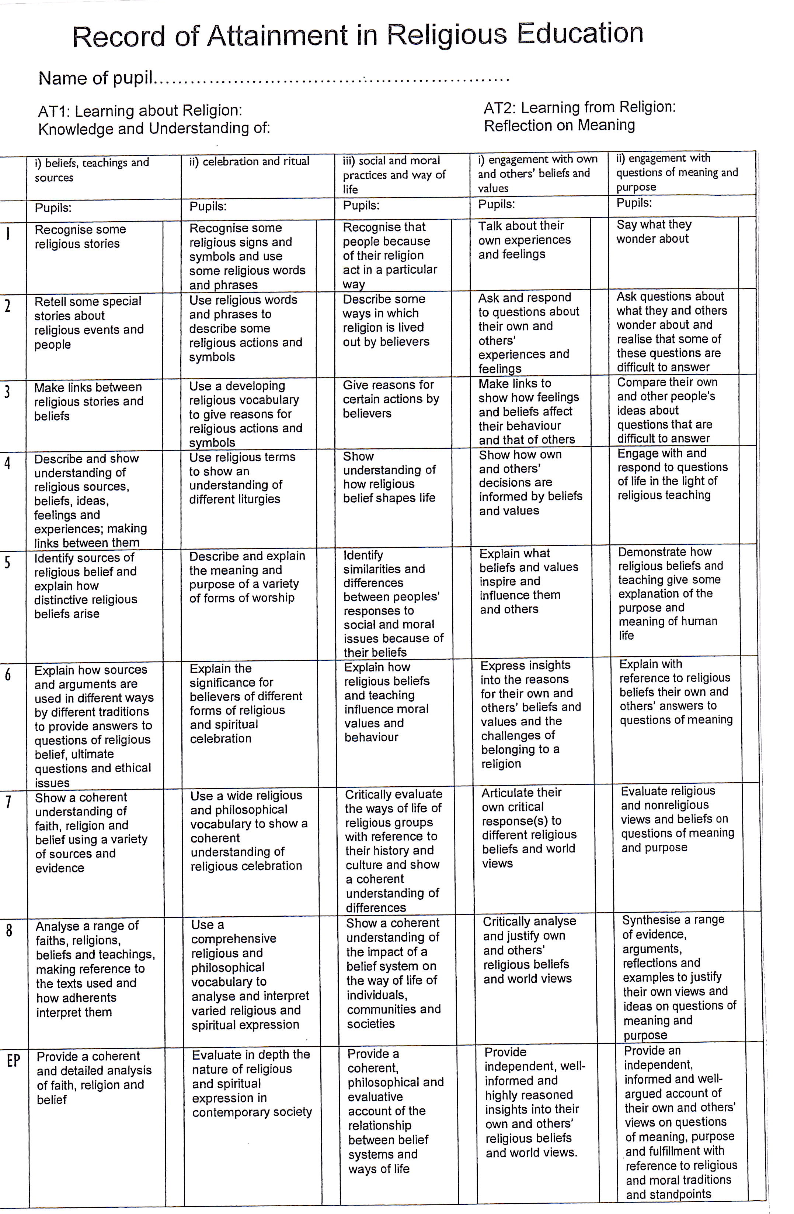
At Our Lady’s we follow the attainment targets and levels of attainment as outlined by the Bishop’s Conference:

how to deliver the programme
Recording

We record achievement in several ways:
- All children in Years 1-6 have a Come and See book where all their written work is recorded. Books are marked by the class teacher and commented upon as appropriate in accordance with our marking policy. These books are monitored by the co-ordinator and the head teacher.
- The Reception class has portfolios of work for each topic. Examples of recording in these books may be photographs of role play, group work, drawings or annotated work.
- At the end of each topic the children record what they know now in their books.
- Photographs are taken throughout topics and may be used on display or collated in individual class portfolios.

Reporting

At Our Lady’s, reporting is completed in a variety of ways:
- Discussion with the children about their work. This is done by the class teacher and should provide positive comments on their achievement and progress.
- Termly assessment. Our assessment procedures should inform other teachers of the achievement of individual pupils.
- Annual report to parents. This allows for teachers to comment on the progress, strengths and achievements of the children.
- The RE co-ordinator submits an RE action plan to the head teacher and Governors.
- The RE co-ordinator informs the parents of the RE topics and content for each year group each term in the RE newsletter.
- After the monitoring process the RE co-ordinator gives feedback to staff.

Evaluation of Teaching

At Our Lady’s, teaching is reviewed and evaluated by the teacher at the end of each lesson and recorded on the short term planning sheet. RE is monitored by the Head Teacher and RE co-ordinator.
- The RE co-ordinator and /or Head Teacher observes RE lessons as part of the monitoring cycle. Individual written and verbal feedback is given to each teacher and generic feedback is given in staff meetings. An overall evaluation report is compiled identifying key areas of strength and development to further support the development of Religious Education Teaching.
- The RE co-ordinator also monitors short term planning, pupil books, reviews RE displays, interviews pupils and staff, all as part of the monitoring cycle.
- Teachers update their individual pupil profiles during the formal assessment process and all teaching staff take part in reviewing and moderating samples of work.

15
Evaluation of Learning

Children are encouraged to evaluate every lesson verbally in a plenary. This encourages children to recall points of interest and retain new information.

During the remember sessions, the teacher enables the children to recall and review the work done in the topic. The teacher helps the children to hold on to, and make their own, what they have understood of their own experience and of the experience of the Church community during the Renew sessions.

Teachers use a variety of methods during Renew sessions to enable children to hold onto new learning.

Staff Development

At Our Lady’s we are fully committed to the development of staff training to ensure the highest quality of teaching and delivery of ‘Come and See’.
All staff are given the opportunity to complete RE courses where appropriate. The co-ordinator attends the termly RE co-ordinator meetings and ensures all relevant information is disseminated to the staff.
Newly Qualified teachers attend relevant training to further their understanding of the RE curriculum.
Collective worship is modelled by experienced staff.
Staff within each Key Stage engage in joint planning to ensure continuity and progression across all classes.

If identified, support in Religious Education teaching is provided according to the professional development needs of staff.
Staff are encouraged to use Come and See to further their knowledge.

Staff Induction

All new members of staff receive a staff induction. This introduces them to the school ethos and mission statement. Newly qualified teachers plan with an experienced member of staff who, along with the R.E co-ordinator and Head Teacher, is willing to help and answer any questions.

All new members of staff will receive a copy of the RE handbook and are introduced to RE resources. New members of staff are also given the opportunity to attend a ‘Come and See’ topic days to help broaden their knowledge.

Staff Communication

Staff meetings are held to discuss the teaching of R.E and the delivery of ‘Come and See.
Time is also given to feedback from staff who have attended relevant R.E Inset/ courses.
Staff regularly discuss the R.E topics with the R.E co-ordinator formally and informally.
All staff plan collective worship for whole school celebrations, key stages and classes.
how to deliver the programme

Relationship of RE to the whole curriculum

Collective Worship

Our Lady’s Catholic Primary School in its approach to Collective worship endeavours to take into account the religious and educational needs of all who share in it.

The Act of Worship is in accordance with rites, practices and beliefs of the Catholic Church. It is the responsibility of the governors. Every child has the opportunity to participate in daily worship.

Parents have the right to withdraw their child from worship if they so choose.

There will be daily acts of worship within each class, key stage or as a school.

Opportunities for Spiritual and Moral Development

Children will be given opportunities which will promote their spiritual and moral development not only through the RE curriculum and liturgical celebrations but in all aspects of school life.
We seek to promote a Catholic setting where loving Christian relationships are developed and that we develop all our children to their full potential. To achieve this we aim to develop an atmosphere where positive relationships are valued and encouraged. We aim to ensure an experience of acceptance and tolerance within school situations and to nurture trust.
This is evident in policies such as Behaviour, Bullying, Relationships and Sex education and through assemblies.
We strongly believe that the Christian perception should permeate the entire curriculum and seek to recognise, affirm and celebrate the gifts and talents of all our children,

Links with Parents

All parents are given a welcome pack containing relevant information about our school.
Each term the RE coordinator produces a newsletter informing parents of the ‘Come and See’ topics for the term. We encourage parents to link home life with the topics pupils are covering. Each topic is explained and aims are outlined so that the parents have the opportunity to become part of the R.E Education in their children’s lives.
Parents and parishioners are invited to join with our children in all whole school assemblies, school masses and productions throughout the year.

Parents are encouraged to attend Parent’s and Open Evenings with their child’s class teacher and discuss their child’s progress across the curriculum.
Parents of children with S.E.N are invited into school in order to discuss their child’s progress on other occasions.
The school is assisting the parishes with the new sacramental programme ‘With You Always.’ Parents of Year 3 (for Year 4 the following year) preparing to receive sacraments were invited to attend a presentation which was led by the parish catechists. This ensures they are fully aware and involved in their children’s preparation.
Curriculum and class meetings are held to ensure parents are kept informed of their child’s education and any new strategies that may be put into place – for example English or Mathematics initiatives.
We also invite parents to become involved in the education of their children in school through helping within the classroom, listening to readers, accompanying classes on trips or helping with costumes for productions.
We have a P.T.F.A. who work very hard to raise extra funds for our school, this also helps to strengthen our home/ school links.
Parents are kept informed of what is happening in school through newsletters, which are written by our Head Teacher and staff and are distributed to children.

Links with our parish

Our Lady’s Catholic Primary School has close links with the Parish Community. Members of the Parish are invited to whole school Masses and celebrations.
The Parish of St. Wilfrid is updated on events at school through the parish newsletter.

Inter-relationship between other school policies

Relationships and Sex Education – the school prospectus gives indication of the fact that RE is linked to the whole curriculum. Not only does it give a brief explanation of our approach to RE, but it also specifies the ways in which it is linked to RSE.

Special Educational Needs

At Our Lady’s we recognise that all of our children are special and unique, we aim to provide a broad and balanced curriculum catering for each child’s spiritual, intellectual, aesthetic, physical and moral development.

We have a whole school approach to children with Special Educational Needs and we aim to provide a stimulating environment where pupil’s interests are aroused and challenged and by providing extra stimulus and encouragement to those pupils with learning difficulties to allow them opportunities to enjoy success.

We aim also to recognise those pupils who need stimulation to challenge them to reach their full potential.

We recognise the vital need for partnership with parents and other agencies. These will include parents, the Archdiocese of Liverpool and Halton LA.

Information and Communication Technology

ICT is used in RE whenever possible. This could include use of interactive whiteboards, the digital camera, audio and visual equipment during lessons and collective worship.

Display

All classrooms have a Religious Education display board and a focus table as necessary where children’s work and objects relevant to the particular ‘Come and See’ topic are displayed. Children are encouraged to use this during times of prayer. We aim to use high quality displays to show that we value children’s work and to provide a stimulus for each topic.

Cross – Phase Links

Each Year 6 child is prepared for their transition to Secondary Schools through visits from their staff and visits to the school.

We have excellent relationships with our Catholic college, Ss. Peter and Paul.

We work hard to ensure a smooth transition for our pupils. This provides valuable information about their child’s new school. Pupils visit the secondary School of their choice and staff from the secondary schools visit the children where possible. The children also have the opportunity to attend Secondary School and experience lessons for a day.

The children’s leaving is specially celebrated at the end of the year with a Leavers Mass and assembly. We celebrate their achievements and wish them well for the future.

Equal Opportunities

- All children have the same access to RE activities regardless of their gender, race or cultural background.
- Each child is expected to listen to the views of other people, and respect that sometimes there will be differences of opinion.
- In the delivery of the syllabus the children are introduced to the views, beliefs and cultures of other faiths.

Review

This handbook will be reviewed on an annual basis each September.

Annual Planner
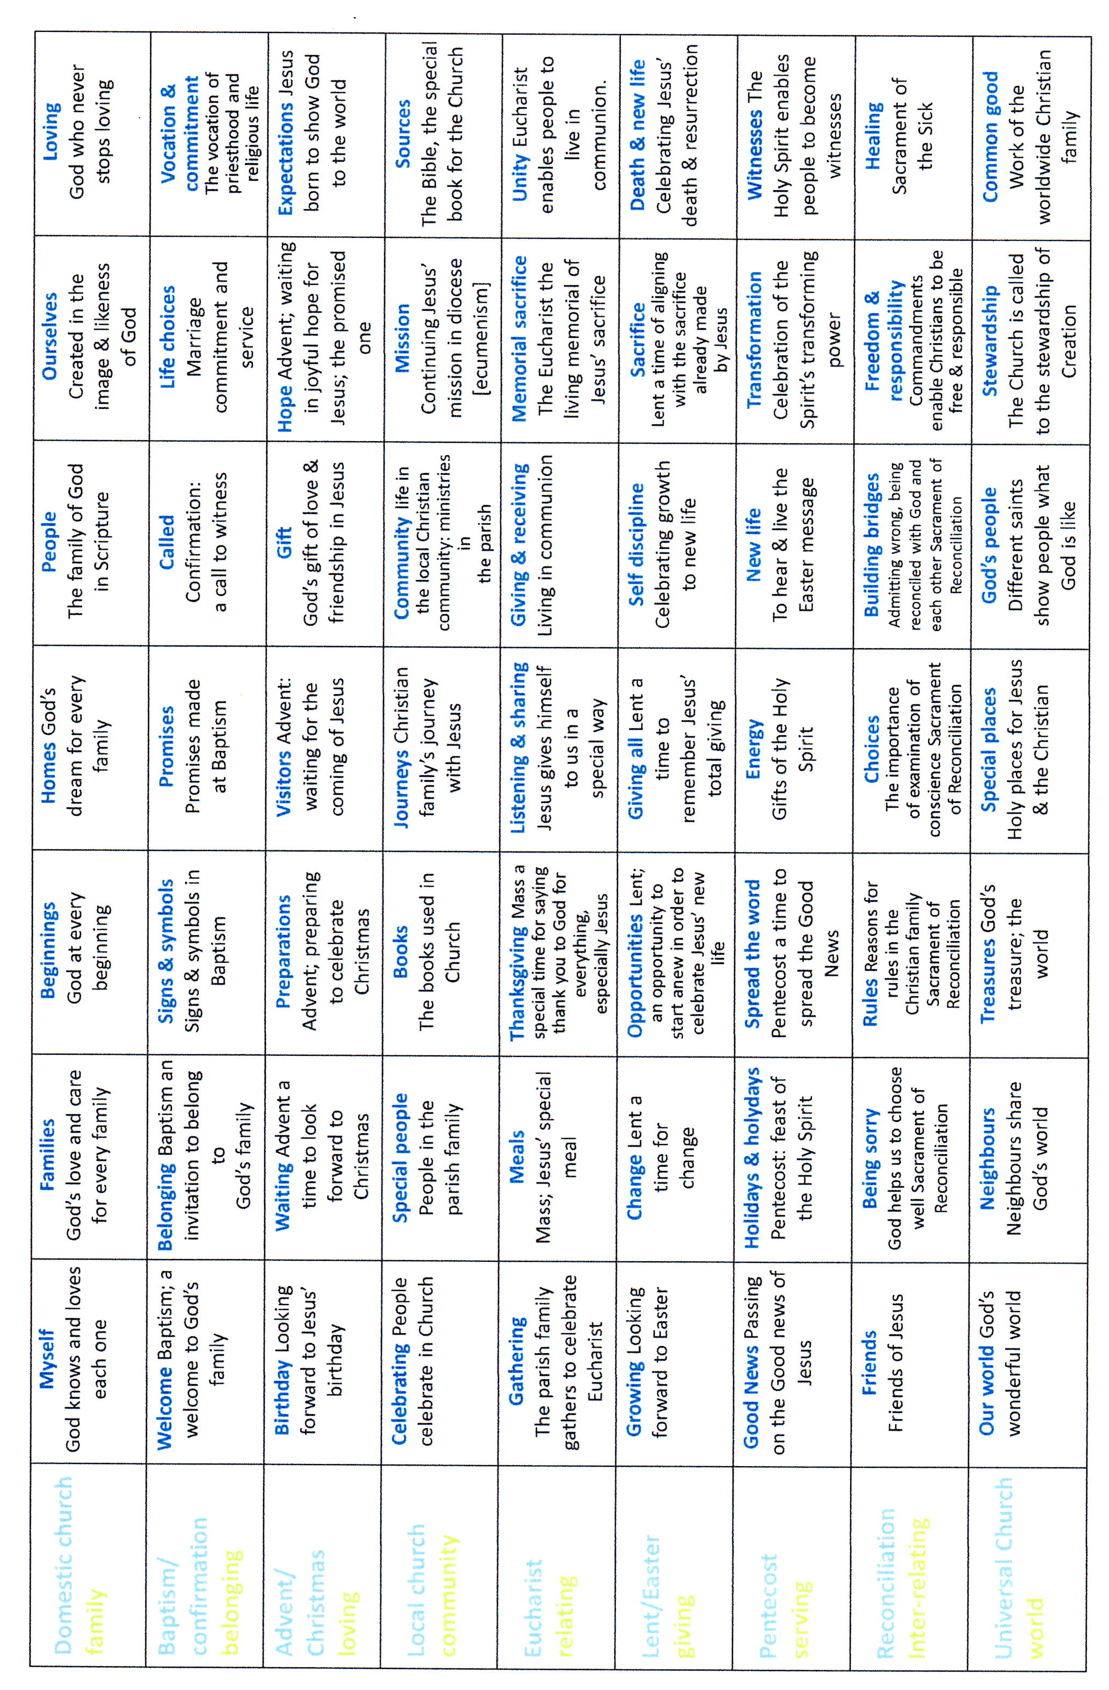

R.E. Resources 2012

Class based:

Reception:

*God’s Story 1
*Church’s Story 1
*Plaque
*Crucifix
*Candles
*Come and See Interactive resources/login details
* Come and See file relevant to year group

Year 1:

*God’s Story2
*Church’s Story 2 (electronic)
*Plaque
*Crucifix
*Candles
*Come and See interactive resources/login details
* Come and See file relevant to year group

Year 2:

*God’s Story2
*Church’s Story 2
*Plaque
*Crucifix
*Candles
*Come and See interactive resources/login details
*Co-ordinator materials/resources
* Come and See file relevant to year group

Year 3:

*God’s Story3
*Church’s Story 3 (electronic)
*Plaque
*Crucifix
*Candles
*Come and See interactive resources/login details
*Pebbles/rocks
* Come and See file relevant to year group

Year 4:

*God’s Story3
*Church’s Story 3 (electronic)
*Plaque
*Crucifix
*Candles
*Come and See interactive resources/login details
*Pebbles/rocks
* Come and See file relevant to year group

Year 5:

*God’s Story3
*Church’s Story 3 hardback and electronic
*Plaque
*Crucifix
*Candles
*Come and See interactive resources/login details
*Statues/figures
*4 Children’s bibles
*10 Good News bibles
*2 Jerusalem Bibles
* Come and See file relevant to year group

Year 6:

*God’s Story3
*Church’s Story 3 (electronic)
*Plaque
* 2 Crucifixes
*Candles
*Come and See interactive resources/login details
* Come and See file relevant to year group
*Glass heart

GENERAL/CENTRAL:

- Box of liturgical drapes
- ‘Other faiths’ boxes:
- Judaism
- Hinduism
- Islamic
- Multi-faith
- 2 Large boxes of Children’s Christian books
- Nativity figures (porcelain)
- Large display bible
- Marian figure
- Vases
- Dry-flower arrangement
- Mission Statement banner
- Holy Communion tapestry
- 35 hymnals
- Marian shrine pictures
- God story – appropriate to age and on desktop.
- Church’s Story on desktops
- Sunday Book of Readings- The Lectionary Adapted For Children- Years A, B and C.
- A selection of assembly books/prayer/sacramental and liturgical books.
- Religious CD’s.
- CD’s suitable for meditation/music co-ordinator.
- A selection of the school library is devoted to R.E. material.
- Costumes for nativities etc…

