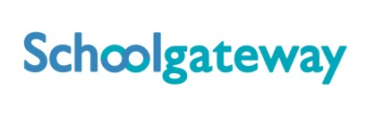
Thursday, 7th July 2016
Dear Parents,
New School Communication and Payments System

As you will be aware we are in the process of moving to an inclusive payments and communications system called Schoolcomms. The system is used across many schools in Halton and fully endorsed by the Local Authority who also provide us with support and maintenance.

Schoolcomms will be the platform through which all school communications will be delivered and includes text messages and emails. However the most efficient and cost effective way to interact with us will be via the School App which all parents are strongly recommended to download.

As from September all payments for trips will be via Schoolcomms and dinner money will move on-line after the October half-term.

Getting Started
It is extremely important that parents do the following to get started on Schoolcomms before the end of term.

- Complete the data collection form – school must have your correct mobile number and email address

- Register with Schoolcomms
  - https://login.schoolgateway.com
  - Click the New User tab
  - Enter your email address and mobile number that is held by school
  - You will then be sent a pin number direct to your mobile
  - Enter your email address again on screen
  - A box will appear for you to enter the pin number
  - Once you confirm the pin number you will be taken through to the School Gateway page
  - Congratulations – you now have a School Gateway account

You will now be able to download the SchoolApp by following the on-line instructions depending upon your type of mobile phone.

If you have any problems registering with Schoolcomms please contact our School Business Manager Robyn Middleton on 0151 424 6130 or sec.olpsprimary@halton.gov.uk.

Kind Regards

Mrs P McGuffie
Headteacher

